**The British College**

**KATHMANDU**

**Coursework Submission Coversheet**(individual coursework only)

**Faculty of Arts, Environment and Technology LBU Student Id:**

77171780

Please ensure all information is complete and correct and attach this form securely to the front of your work before posting it in a coursework collection box.

Award name: BSc (Hons) Computing

Module code: GFH230006____________________________________________________________

Module name: DAD (Database Application Development )

Module run: 2016-2017__________________________________________

Coursework title: Volunteer____

Due Date:**16/01/ 2017**

Module leader: (In LBU) _____Sanela Lazarevski____________________________________________________

Module tutor: (In TBC) _____ Rohit Raj Pandey_____________________________________________

**TURNITIN** Checked: YES NO ***(please circle)***

Submission date & time: Date: 16/01/2017 Time: 10:30

**Total Word Count: Total Number of Pages (including this front sheet):**

**In submitting this form with your assignment, you make the following declaration:**  
I declare, that the coursework submitted is my own work and has not (either in whole or part) been submitted towards the award of any other qualification either at LBU or elsewhere. I have fully attributed/referenced all sources of information used during the completion of my assignment, and I am aware that failure to do so constitutes an assessment offence.

Signed: __Sulabh Shrestha Date: ___16/01/ 2017__

**You are strongly advised to retain a second copy of your work in case of any query about the assignment.**

**For checking by the student:**

**For completion by the faculty:**

**This mark is provisional and subject to moderation and approval by the relevant examining board**

**Teacher's Feedback**

**Table of Content:**

1. Table Implemented with views
2. Volunteer
3. Skill
4. Vol_Skill
5. Project
6. Task
7. Skill_Task
8. Task_Activity
9. Project_Contact
10. Travel_Booking
11. Travel_Option
12. Project_Location
13. View
14. Subsystem View 1
15. Subsystem View 2
16. Subsystem View 3
17. View
18. View 1
19. View 2
20. View 3
21. Triggers
22. Trigger1
23. Trigger2
24. APEX Forms/Pages
25. Volunteer
26. Skill
27. Vol_Skill
28. Project
29. Task
30. Skill_Task
31. Task_Activity
32. Project_Contact
33. Travel_Booking
34. Travel_Option
35. Project_Location
36. Master Detail Volunteer
37. Master Detail Project
38. Bar Graph on selected Query
39. Calendar on Task_Activity Date
40. User Guide on Master Detail of Project
41. Appendix 1
42. Appendix 2

# TASK 1: Implemented tables, with suitable data and View.

## Tables Implemented:

1. Volunteer
2. Vol_Skill
3. Skill
4. Skill_Task
5. Task
6. Project
7. Task_Activity
8. Contact
9. Travel_Booking
10. Travel_Option
11. Project_Location

**TABLE**

* + - 1. Volunteer Table

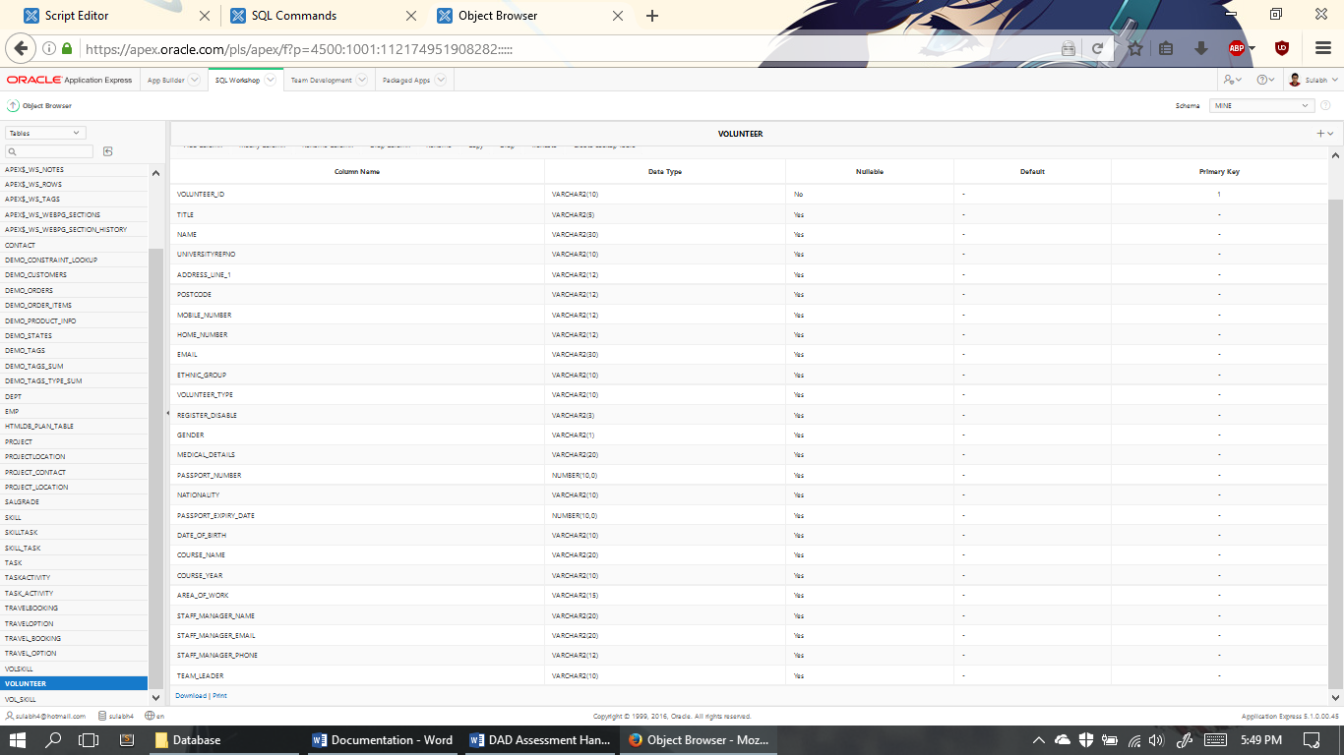

Volunteer_ID is the primary key and is not null. Columns have been well planned and data types carefully considered.

* + - 1. Volunteer Data

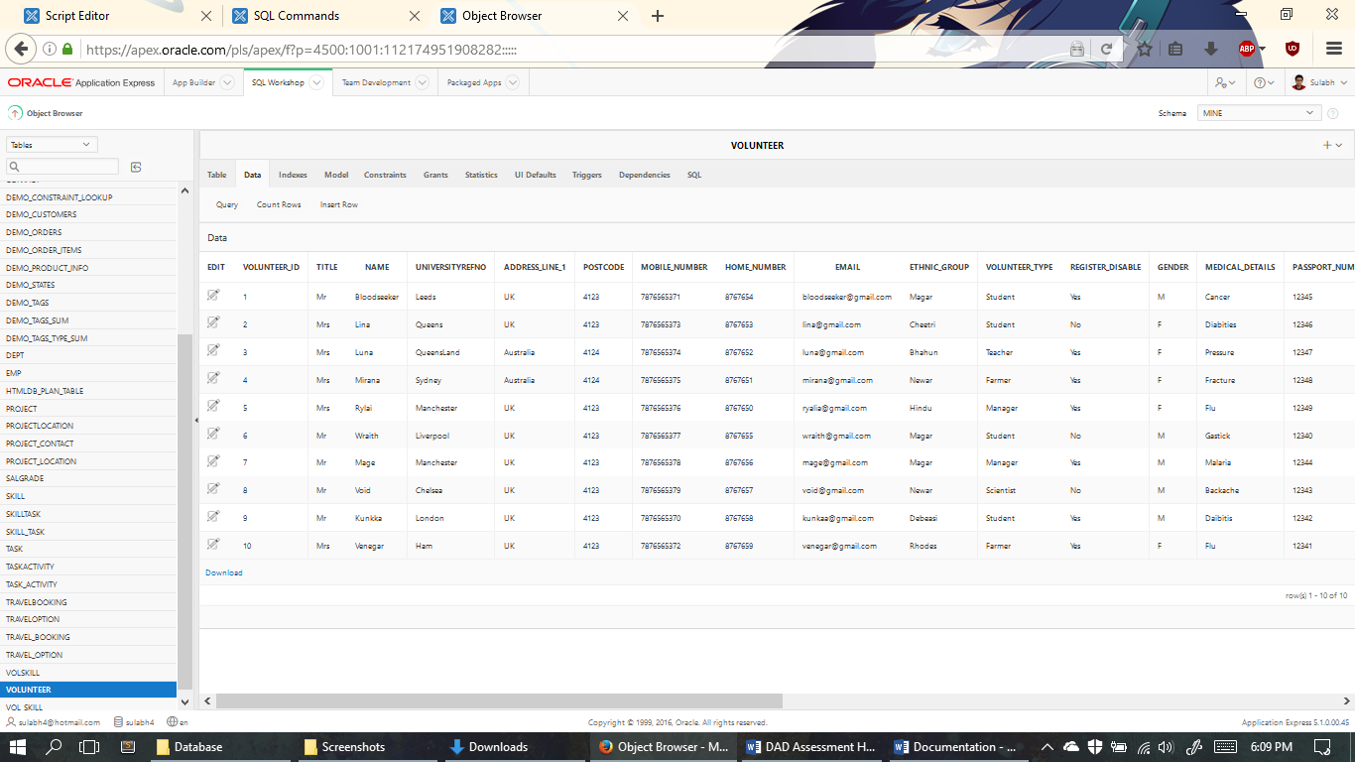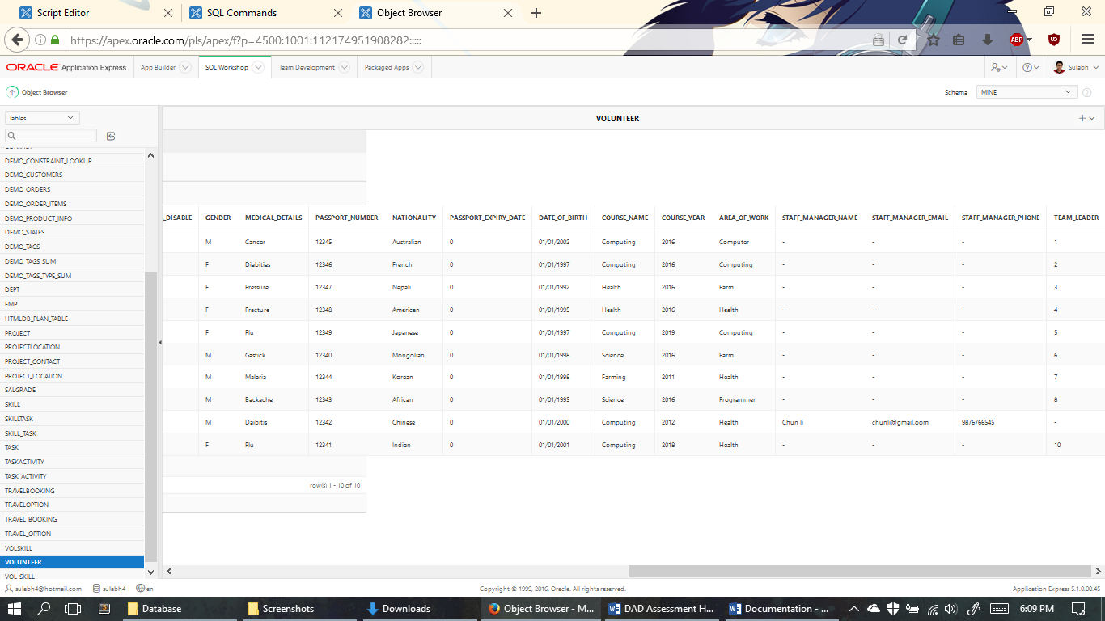

10 data on table have been carefully inserted.

* + - 1. Volunteer Constraints

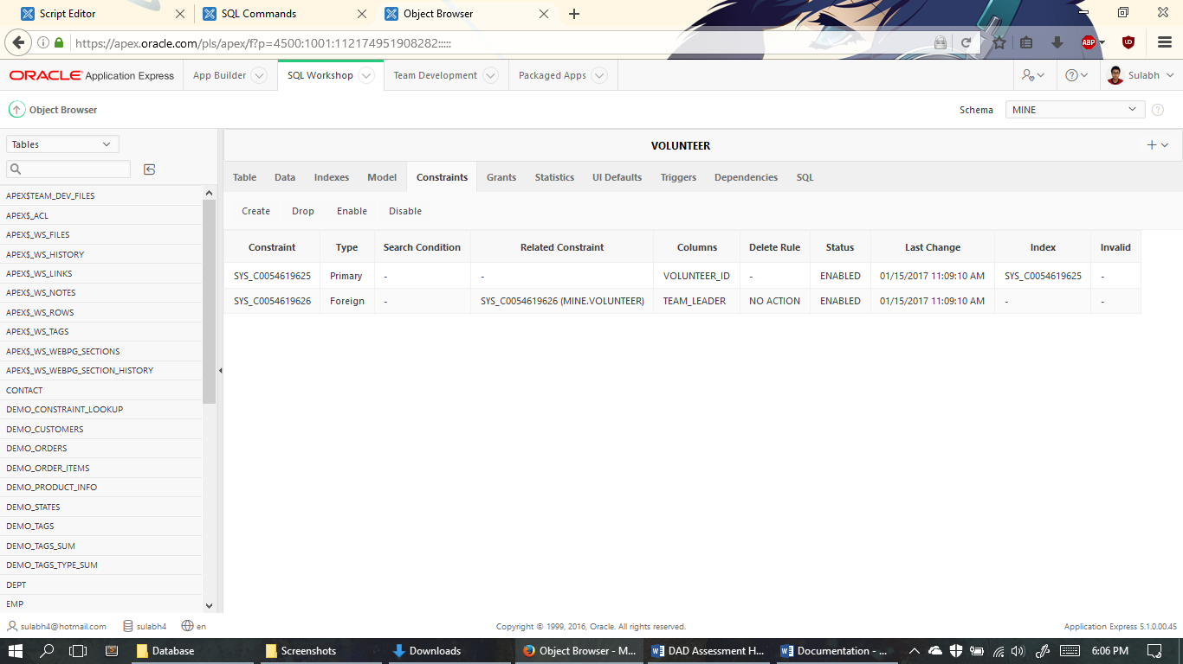

Volunter_id is the primary key which is used as a foreign key in other tables. Team_leader is the foreign Key.

1. Skill Table

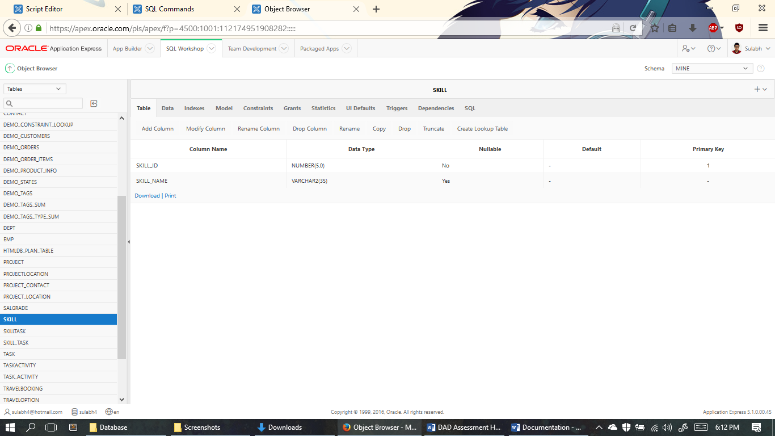

Skill_ID is the primary key and is not null. Columns have been well planned and data types carefully considered.

1. Skill Data

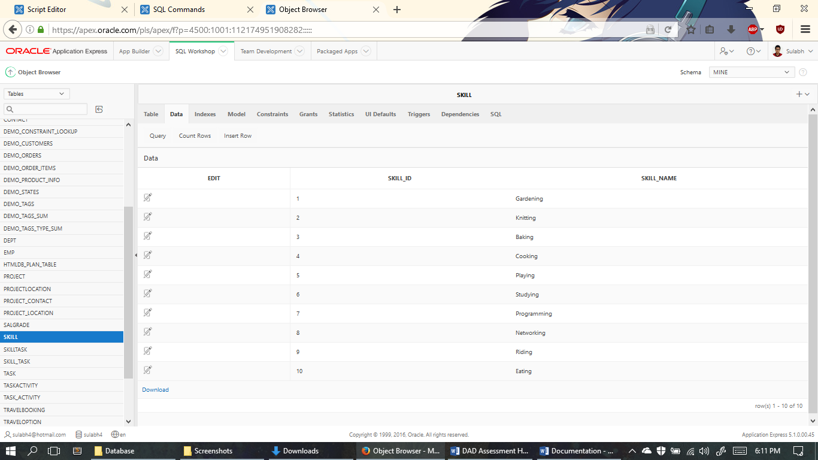

10 data on Skill’s table have been carefully inserted.

1. Skill Constraints

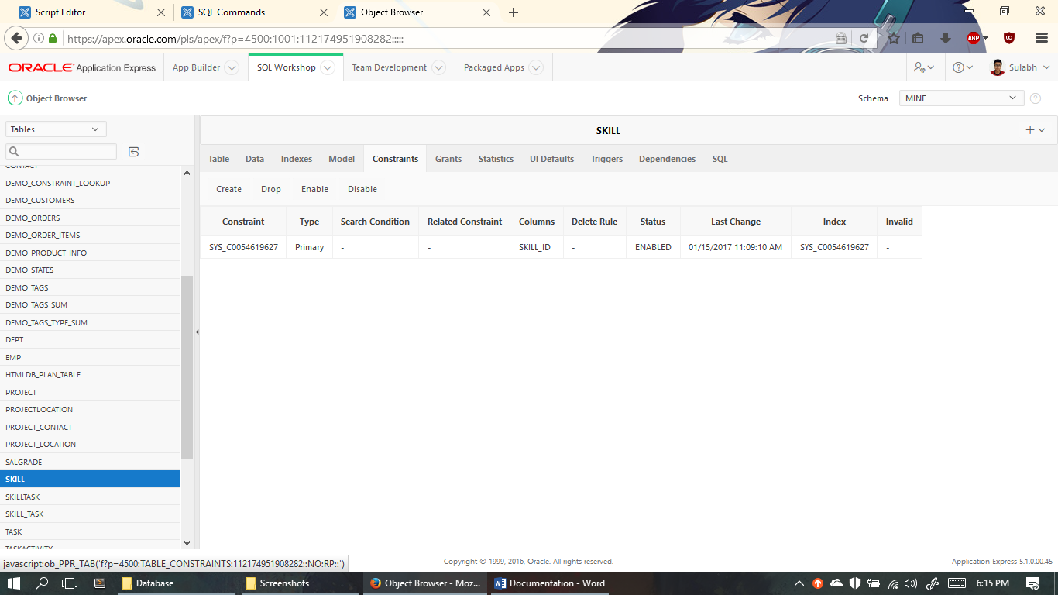

Skill_id is the primary key which is used as a foreign key in other tables.

1. Vol_Skill Table

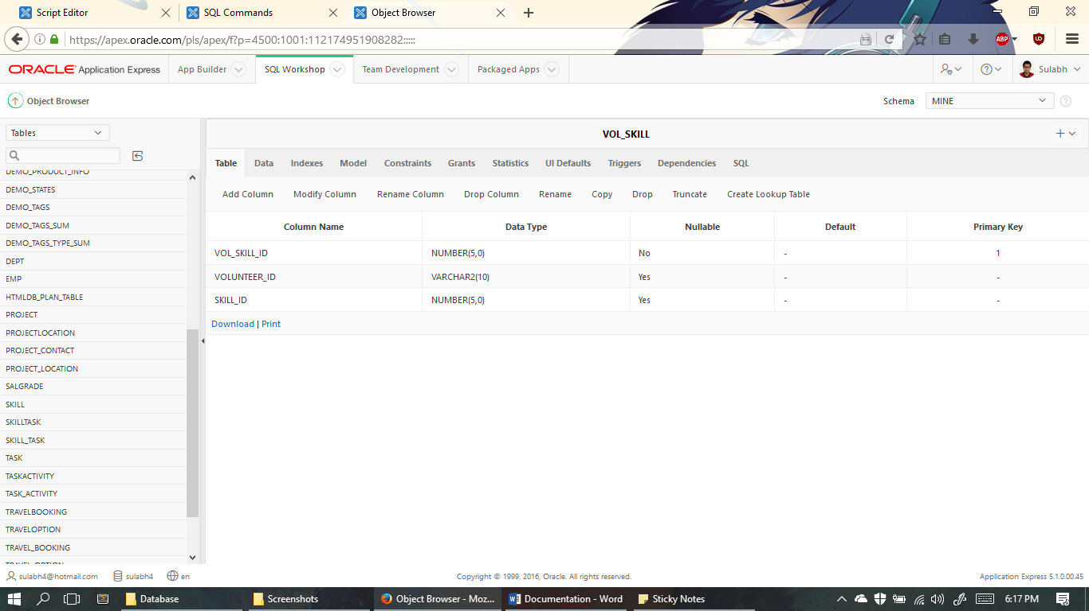

Vol_Skill_ID is the primary key and is not null. Columns have been well planned and data types carefully considered.

1. Vol_Skill Data

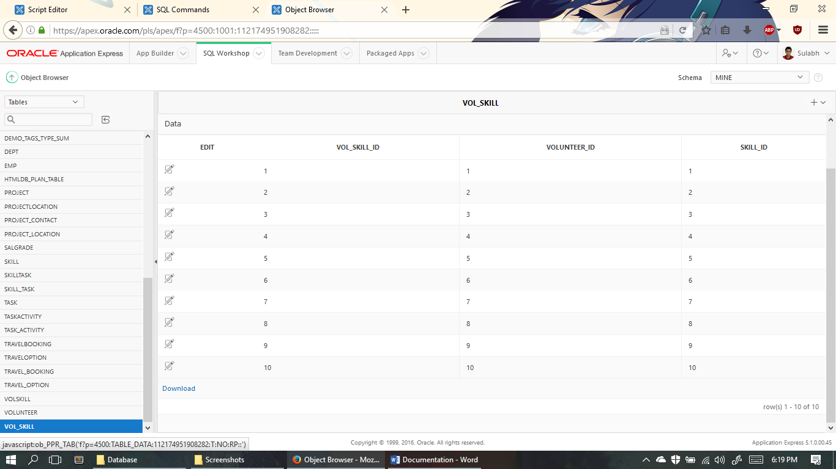

10 data on table have been carefully inserted.

1. Vol_Skill Constraints

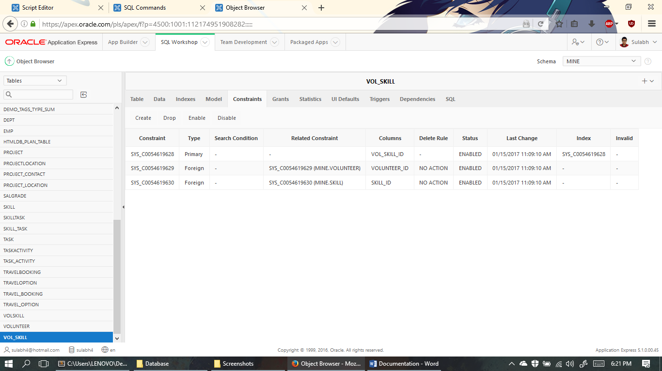

Vol_Skill_id is the primary key which is used as a foreign key in other tables. Volunteer_id and Skill_id are the foreign Keys.

1. Project_location Table

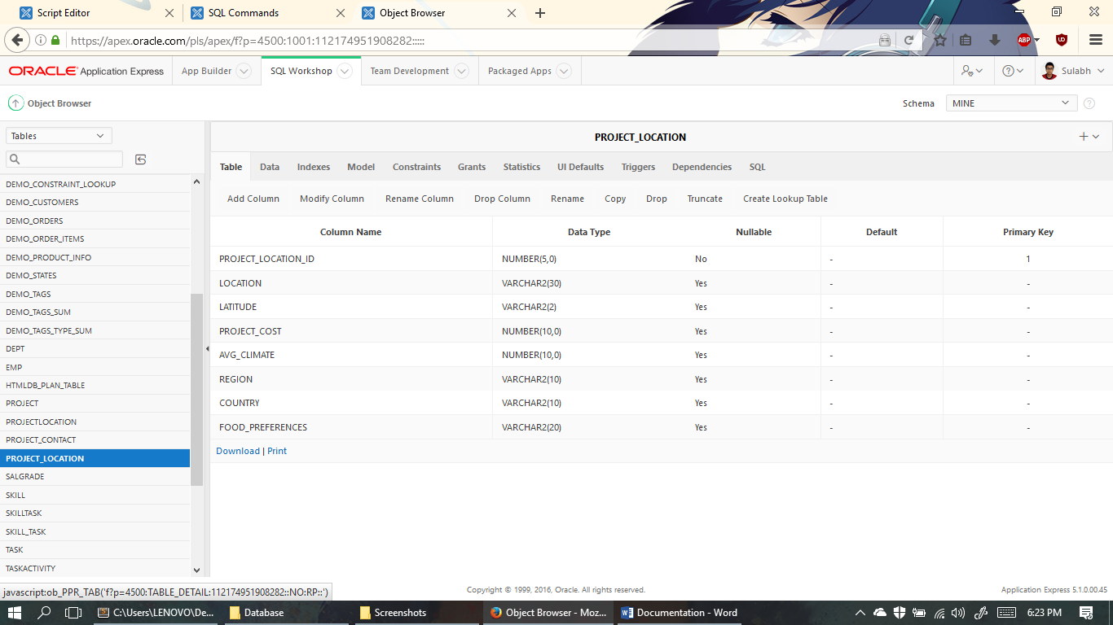

Project_Location_ID is the primary key and is not null. Columns have been well planned and data types carefully considered.

1. Project_Location Data

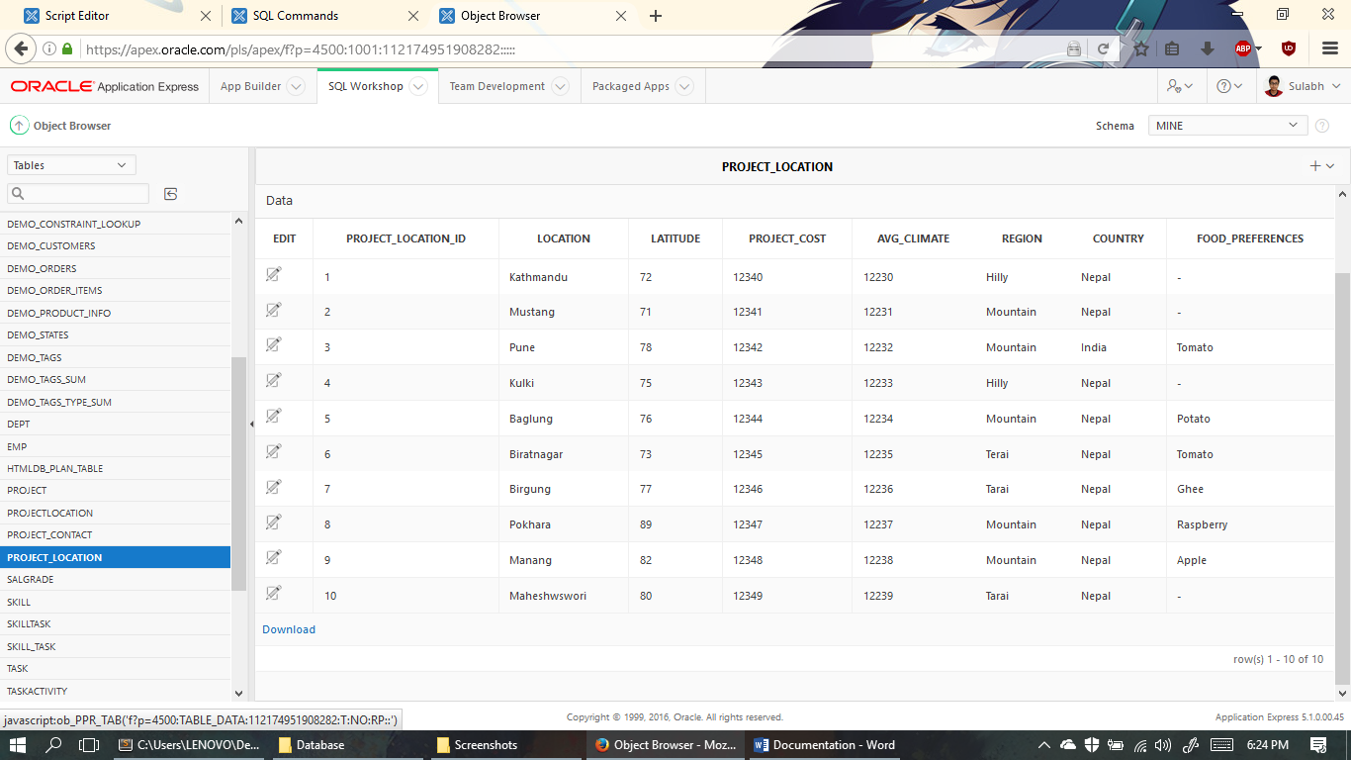

10 data on table have been carefully inserted.

1. Project_Location Constraints

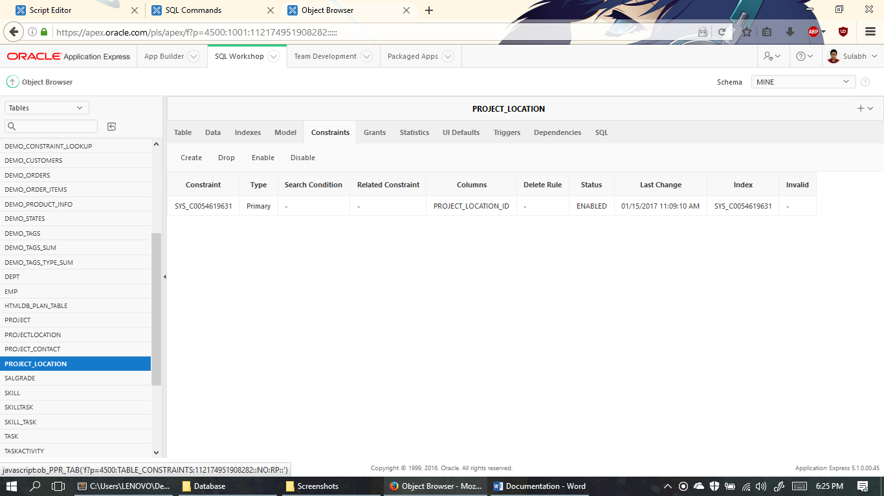

Project_Location_id is the primary key which is used as a foreign key in other tables.

1. Project Table

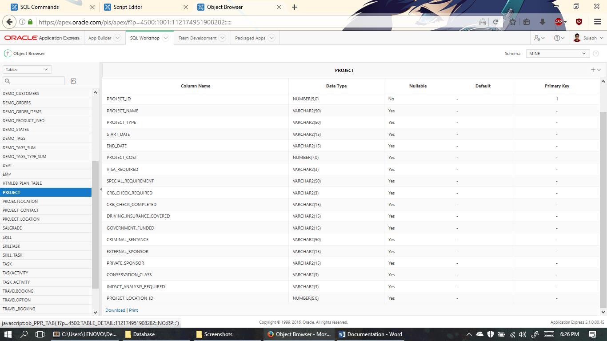

Project_ID is the primary key and is not null. Columns have been well planned and data types carefully considered.

1. Project Data

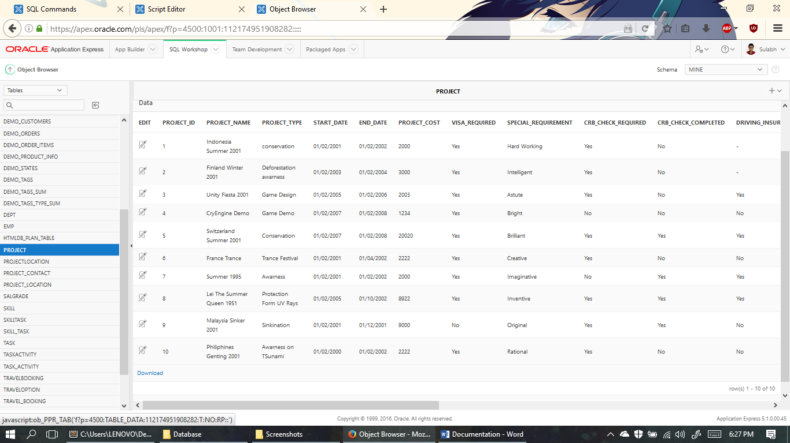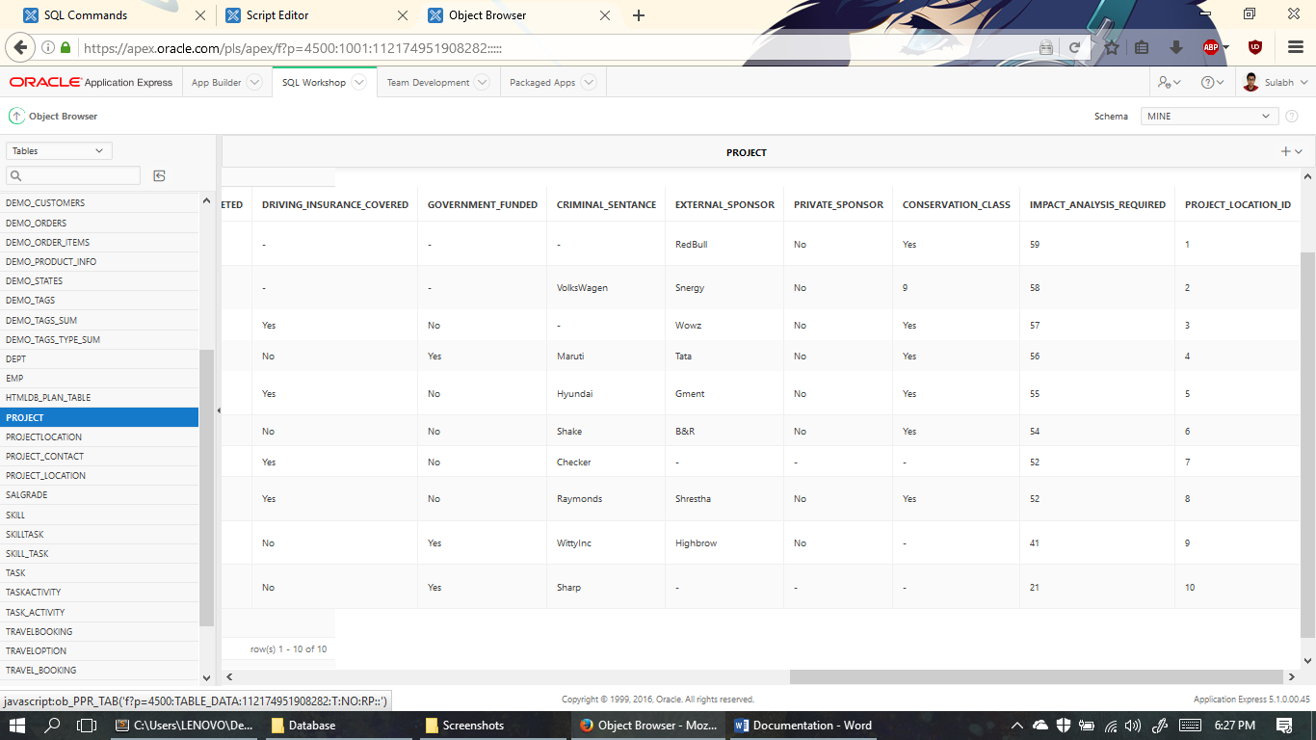

10 data on table have been carefully inserted.

1. Project Constraints

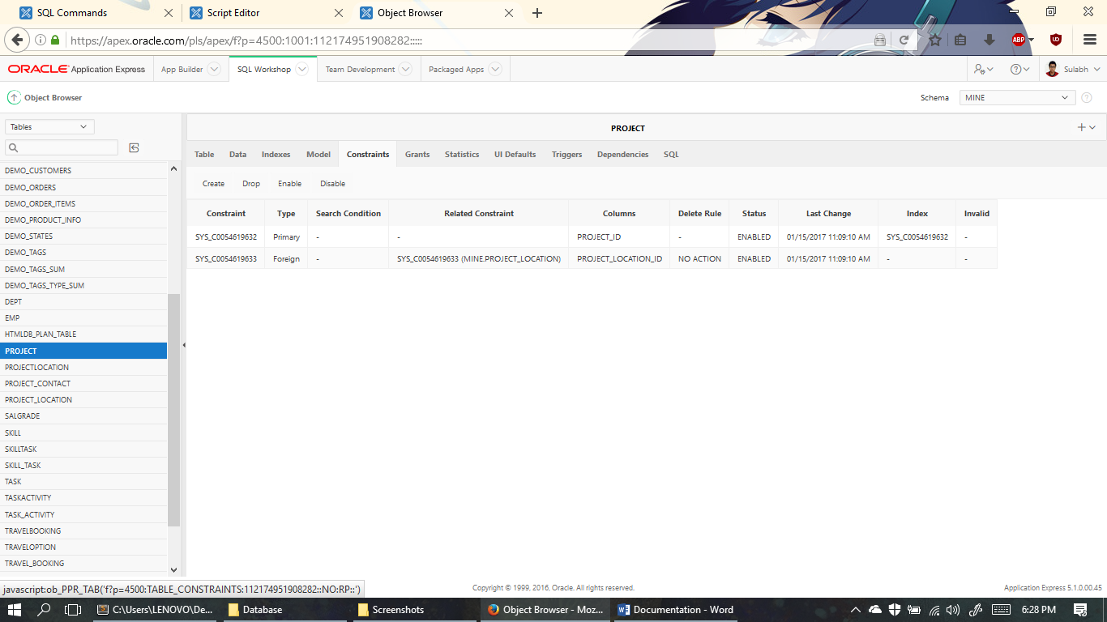

Project_id is the primary key which is used as a foreign key in other tables. Project_location_id is the foreign Key.

1. Task Table

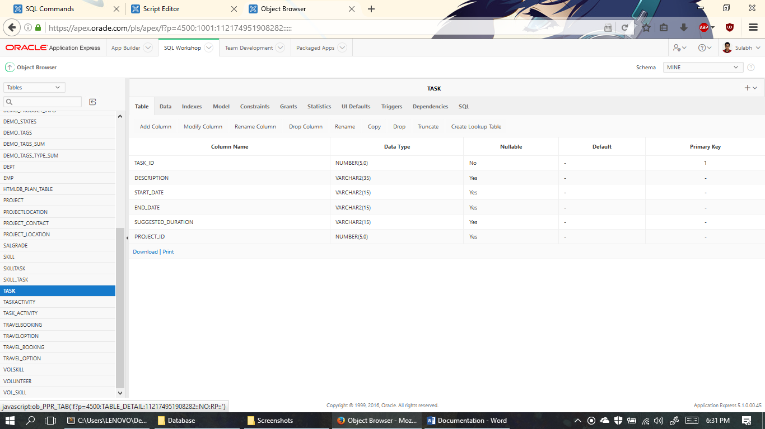

Task_ID is the primary key and is not null. Columns have been well planned and data types carefully considered.

1. Task Data

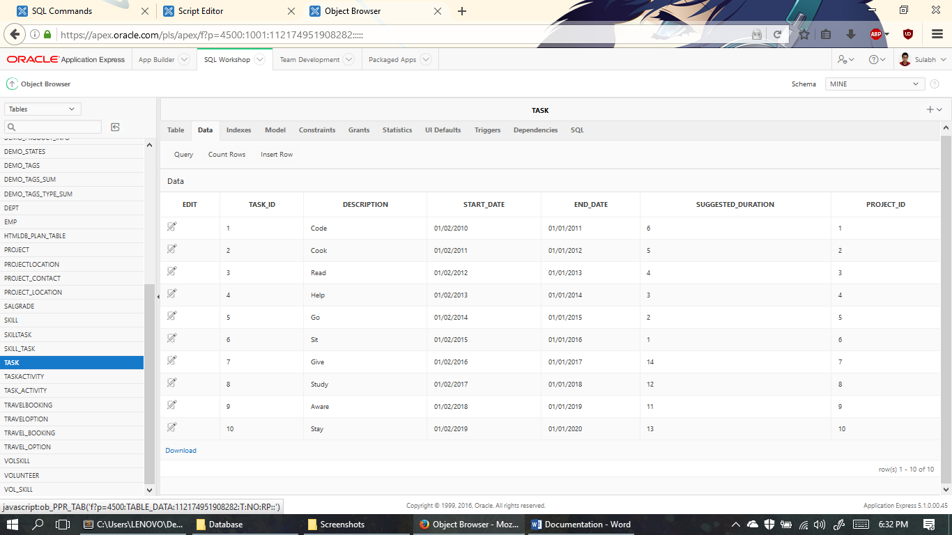

10 data on table have been carefully inserted.

1. Task Constraints

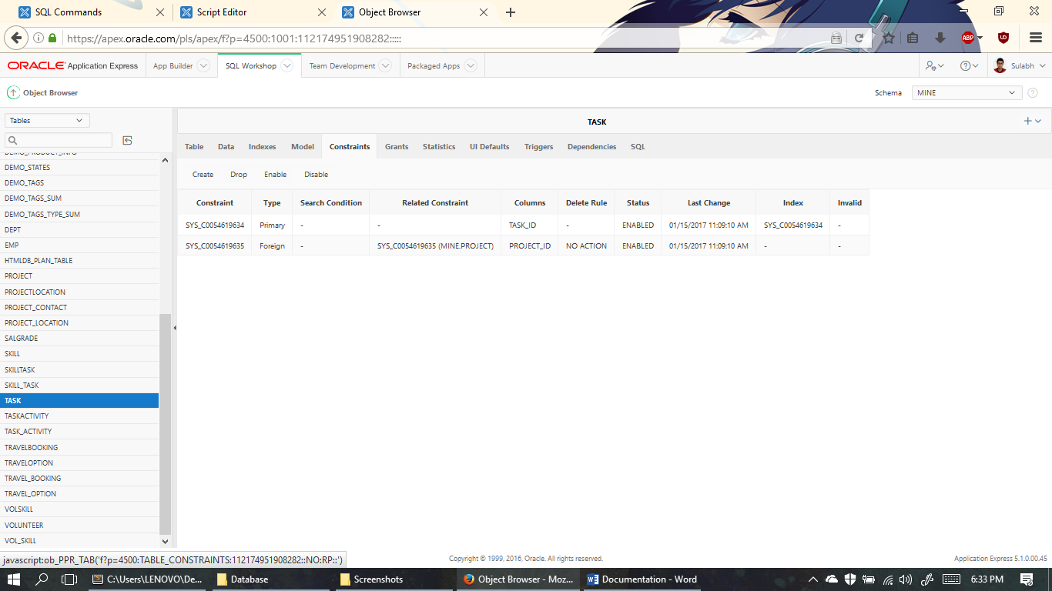

Task_id is the primary key which is used as a foreign key in other tables. Proect_id is the foreign Key.

1. Skill_Task Table

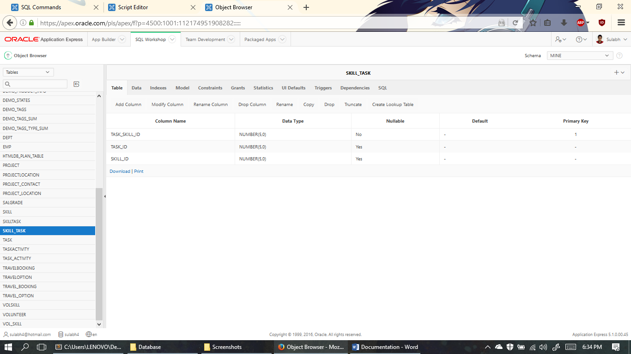

Task_Skill_Id is the primary key and is not null. Columns have been well planned and data types carefully considered.

2. Skill_Task Data

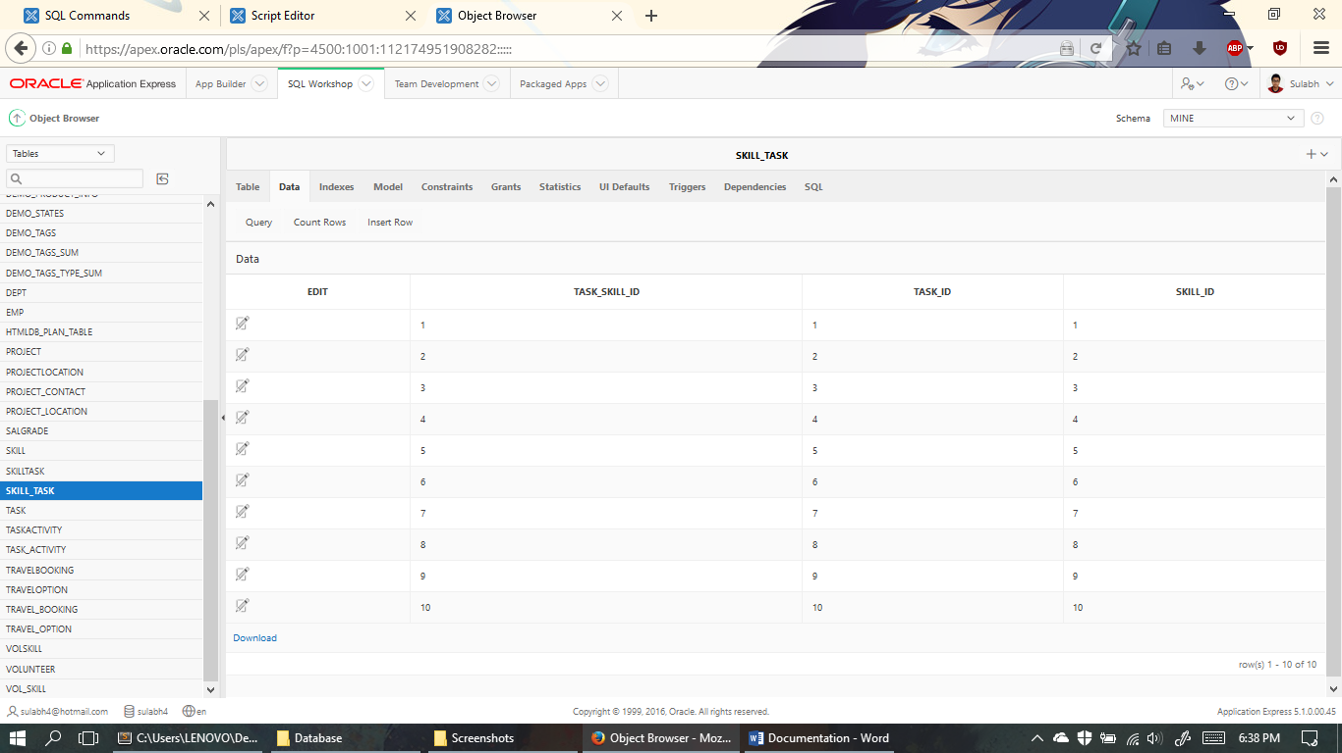

1. Data on table have been carefully inserted.

3. Skill_Task Constraints

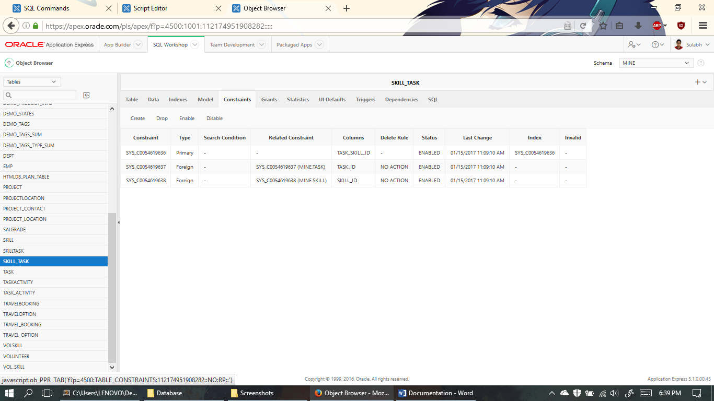

Task_Skill_Id is the primary key which is used as a foreign key in other tables. Task_Id and Skill_Id are the foreign Keys.

1. Task_Activity Table

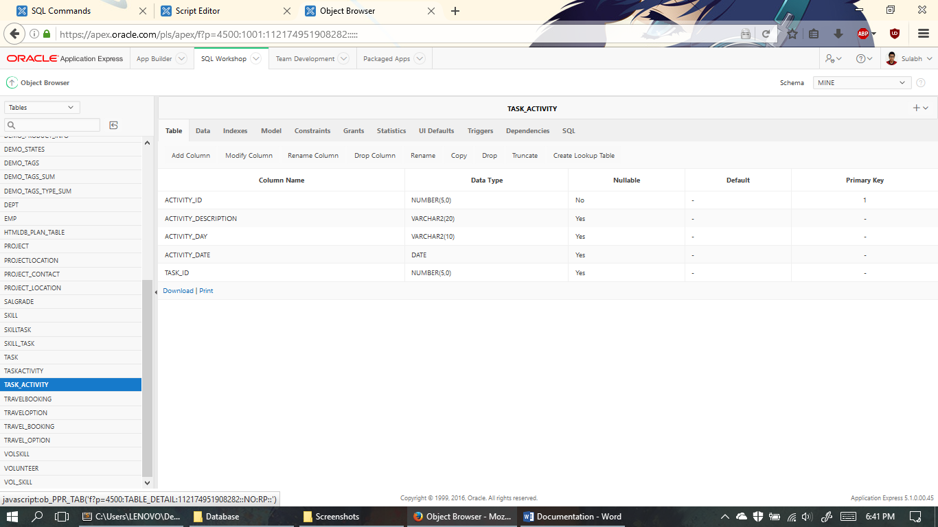

Activity_ID is the primary key and is not null. Columns have been well planned and data types carefully considered.

1. Task_Activity Data

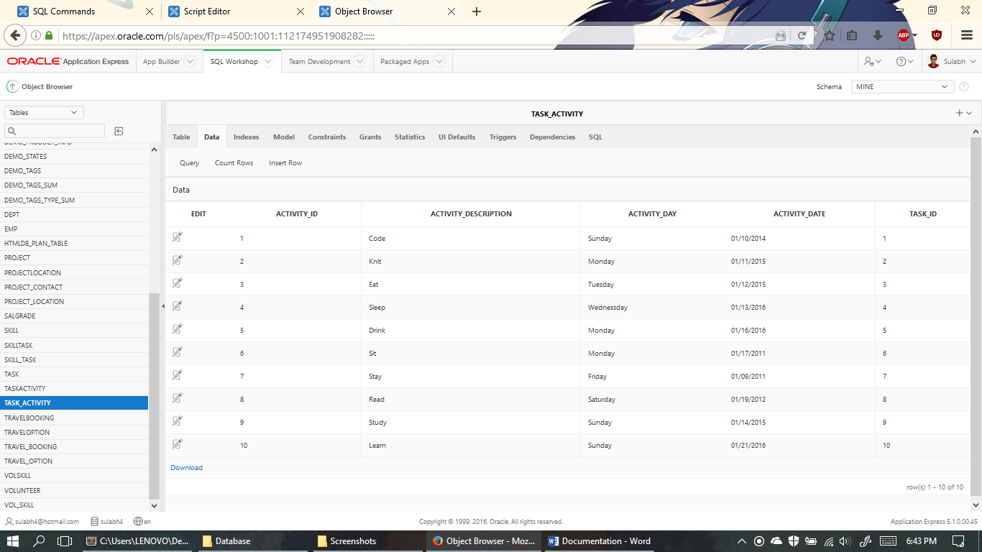

10 data on table have been carefully inserted.

1. Task_Activity Constraints

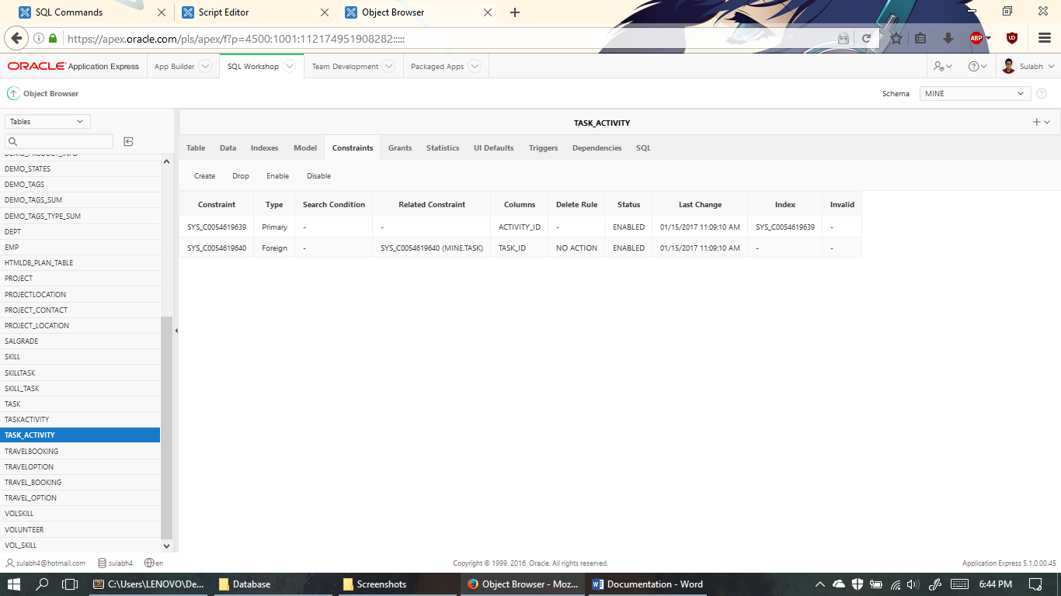

Activity_id is the primary key which is used as a foreign key in other tables. Task_Id is the foreign Key is this table

1. Project_Contact Table

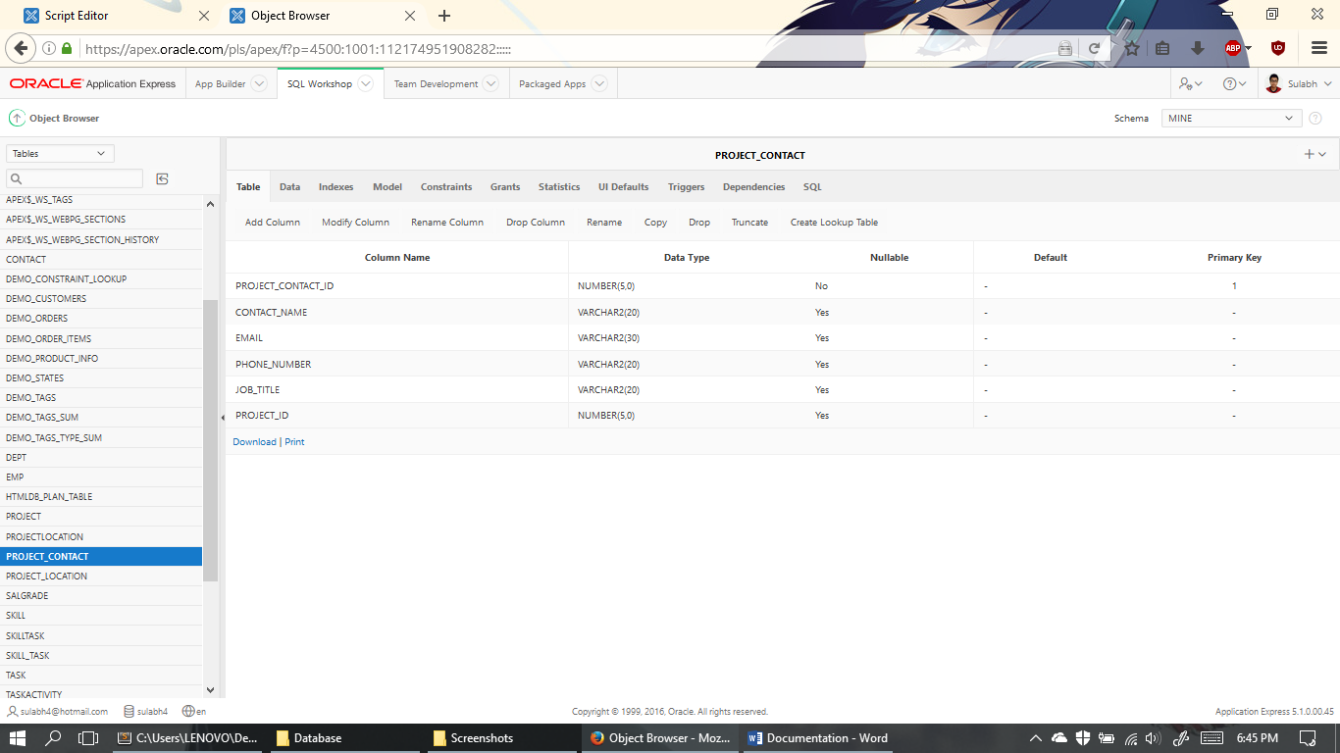

Project_Contact_ID is the primary key and is not null. Columns have been well planned and data types carefully considered.

1. Project_Contact Data

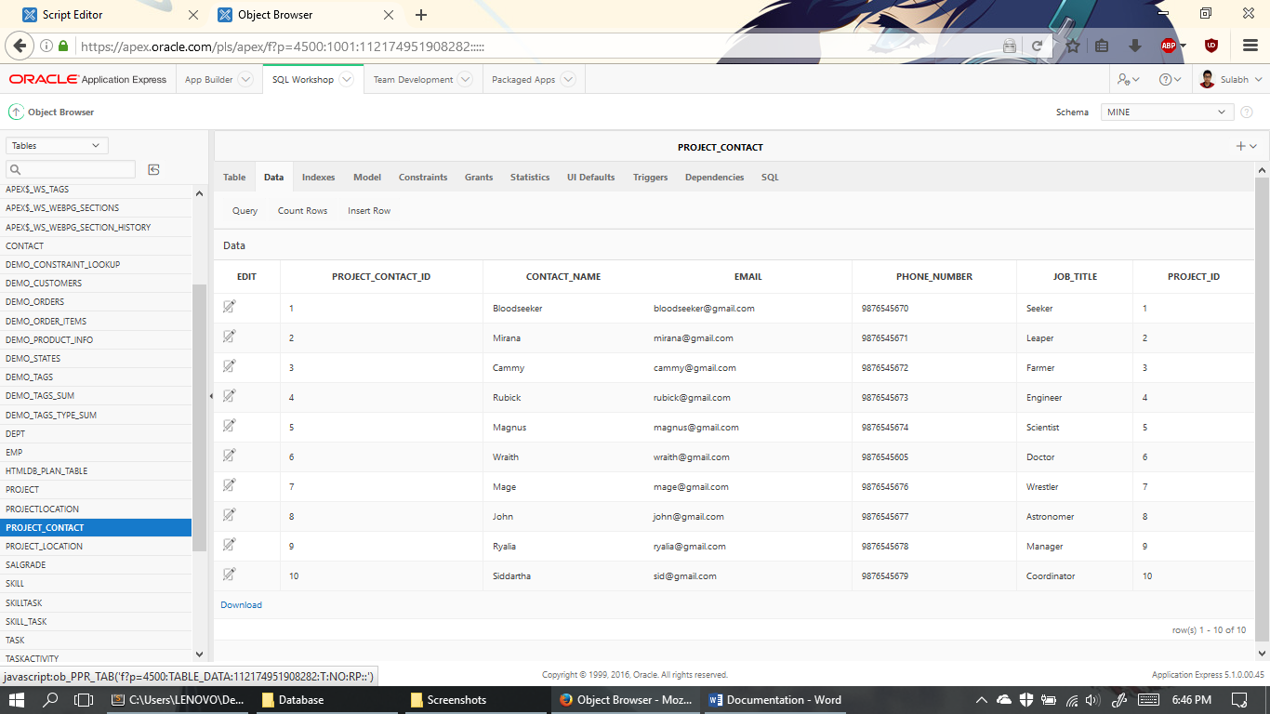

10 data on table have been carefully inserted.

1. Project_Contact Constraints

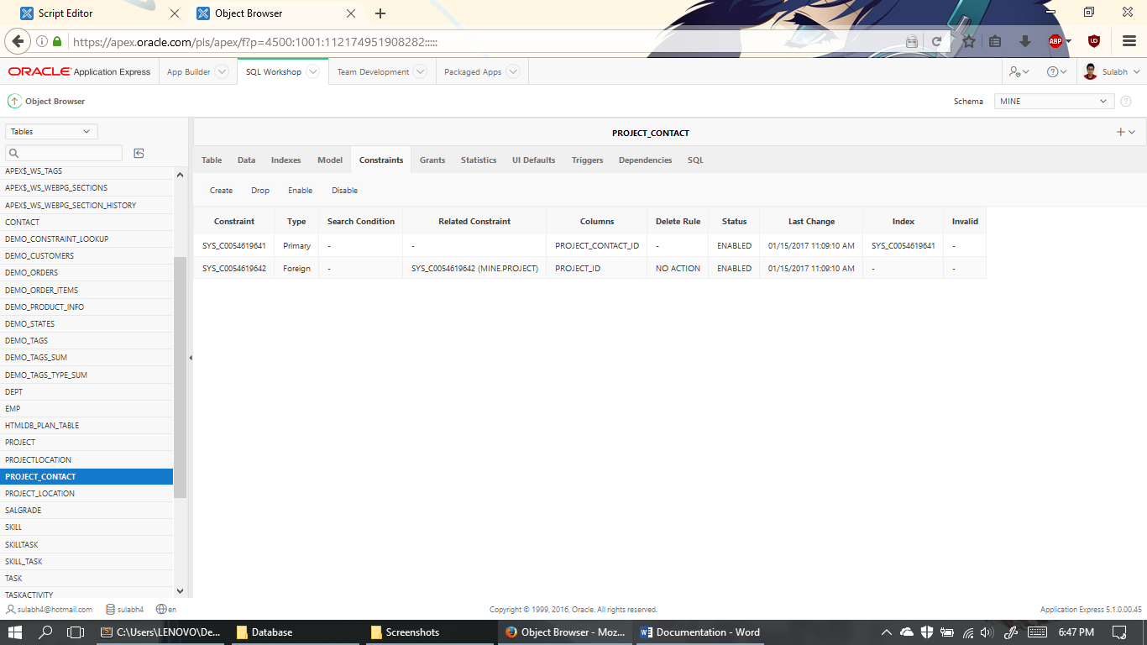

Project_Contact_id is the primary key which is used as a foreign key in other tables. Project_Id is the foreignKey used in this table.

1. Travel_Option Table

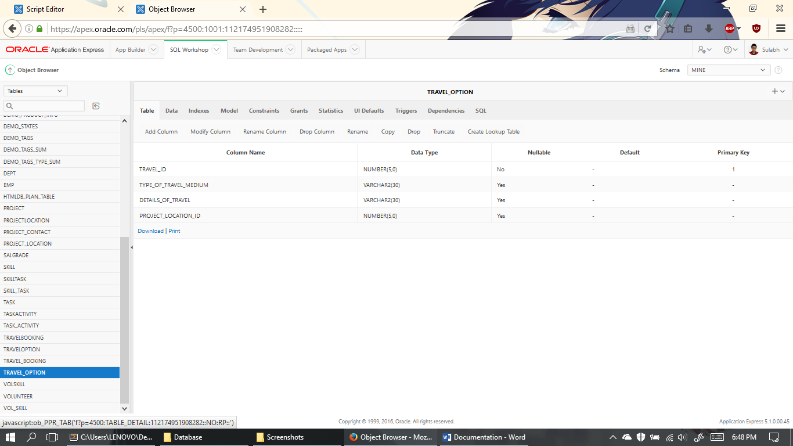

Travel_ID is the primary key and is not null. Columns have been well planned and data types carefully considered.

1. Travel_Option Data

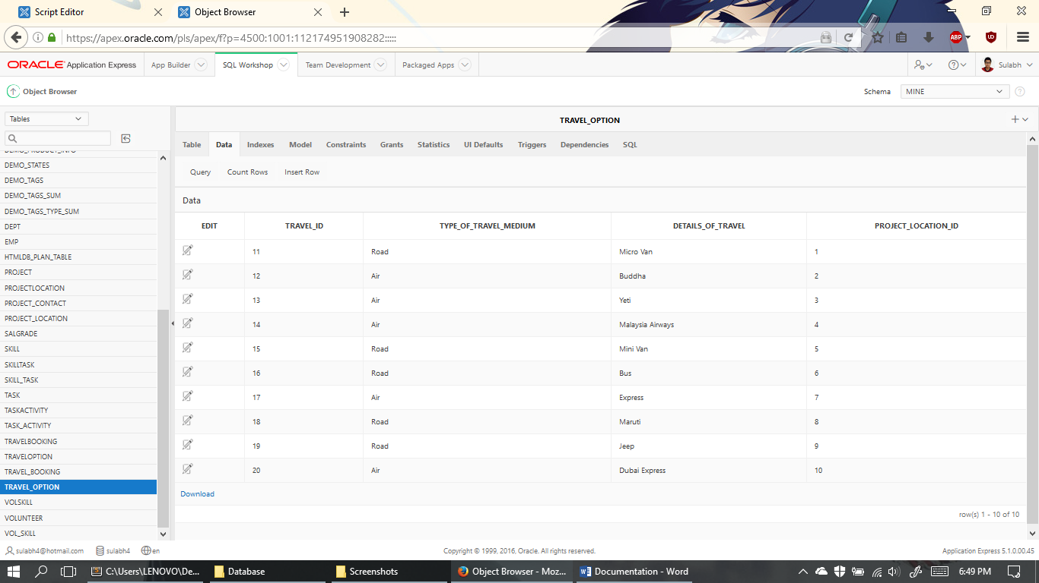

10 data on table have been carefully inserted.

1. Travel_Option Constraints

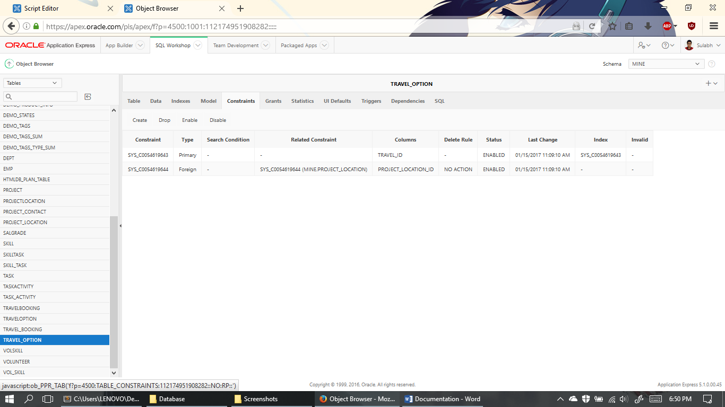

Travel_id is the primary key which is used as a foreign key in other tables. Project_Location_Id is the foreign key which is used in this table.

1. Travel_Booking Table

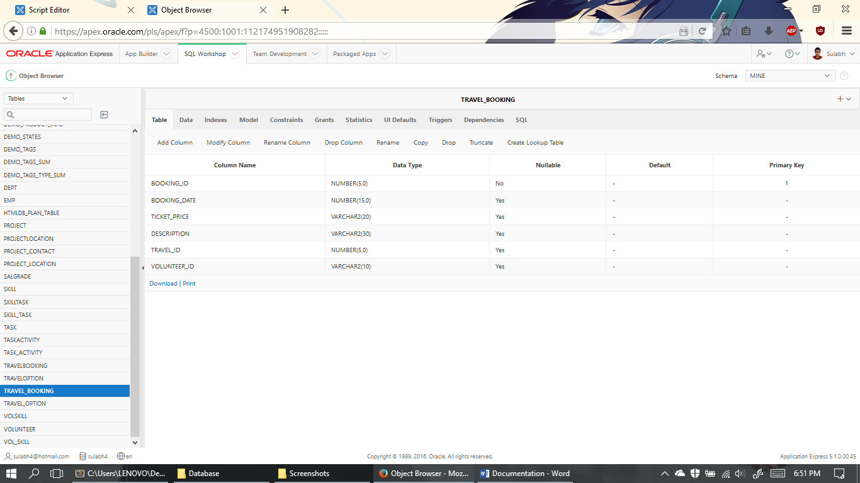

Booking_ID is the primary key and is not null. Columns have been well planned and data types carefully considered.

1. Travel_Booking Data

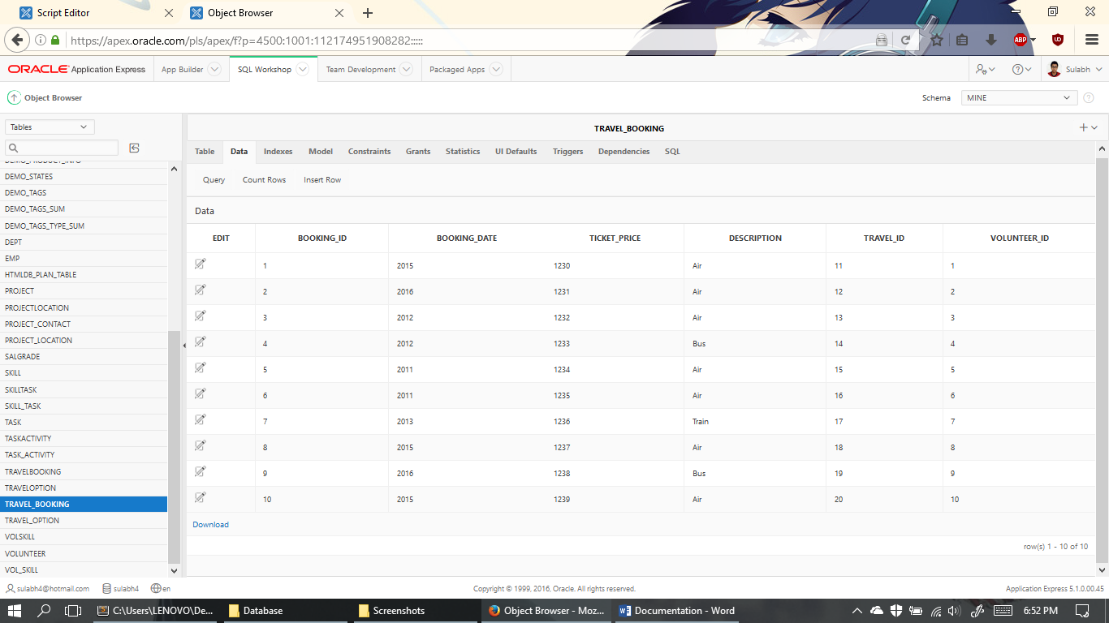

10 data on table have been carefully inserted.

1. Travel_Booking Constraints

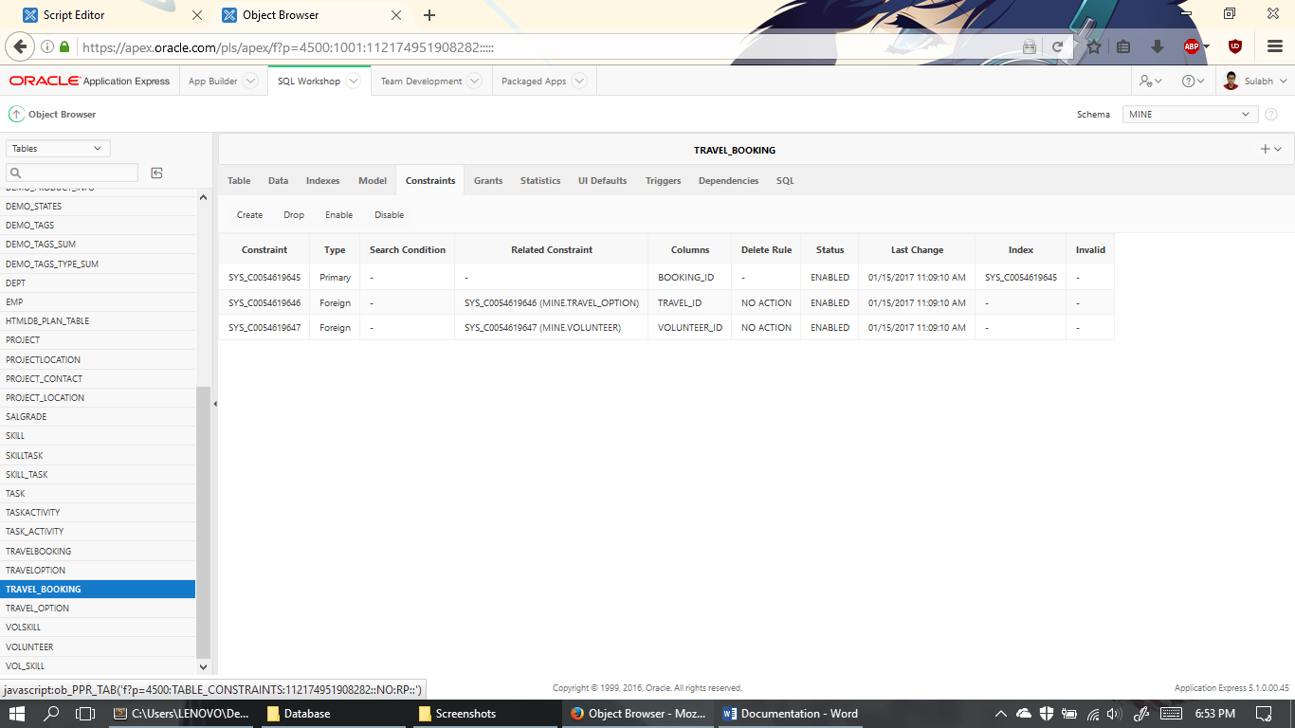

Booking_id is the primary key which is used as a foreign key in other tables. Travel_Id and Volunteer_id are the foreign Keys used in this table.

**View**

1. Subsystem1View Table

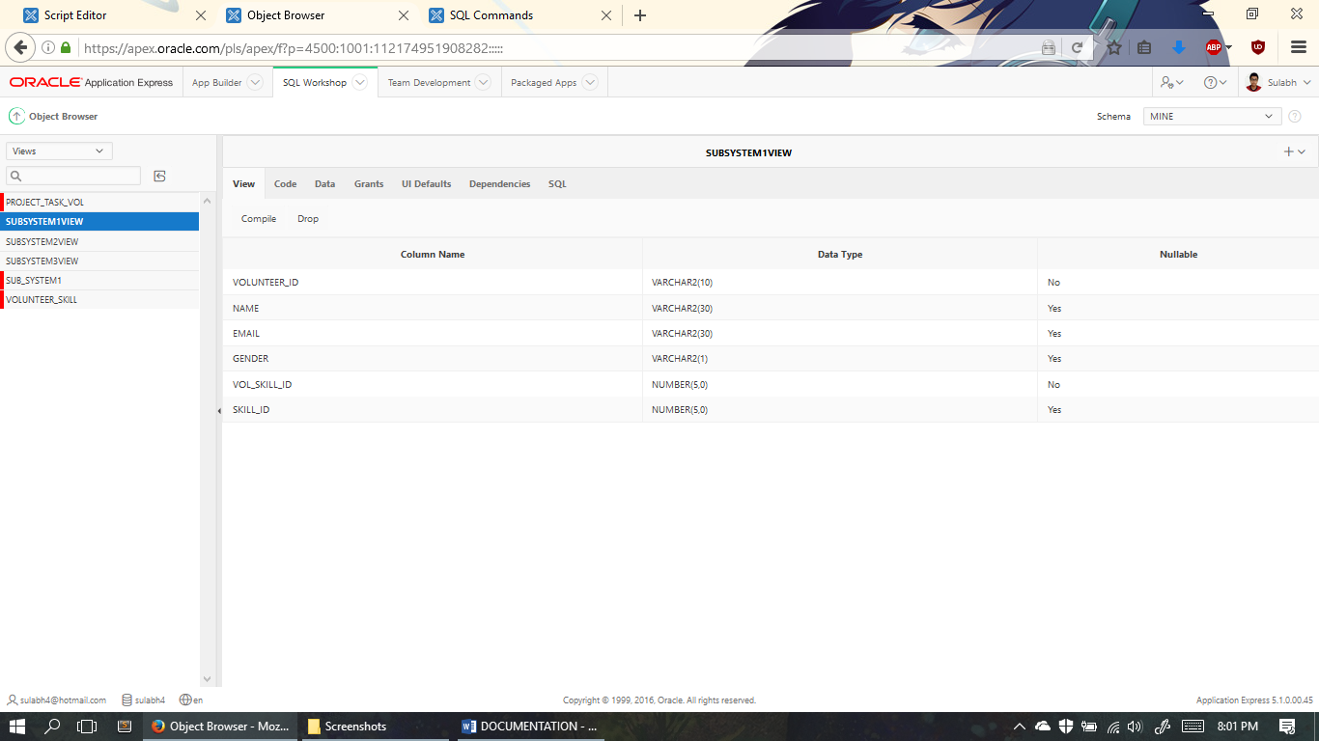

Subsystem1View Table takes volunteer_id, name, email, gender, vol_skill_id, skill_id from tables volunteer & vol_skill

1. Subsystem1View SQL

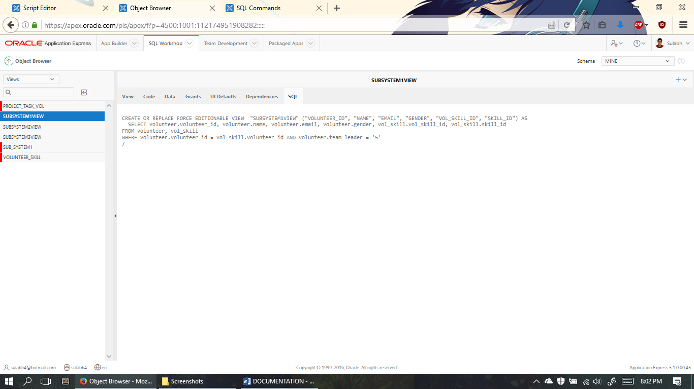

Subsystem1View SQL consists of volunteer_id, name, email, gender, vol_skill_id, skill_id from tables volunteer & vol_skill

1. Subsystem1View Data

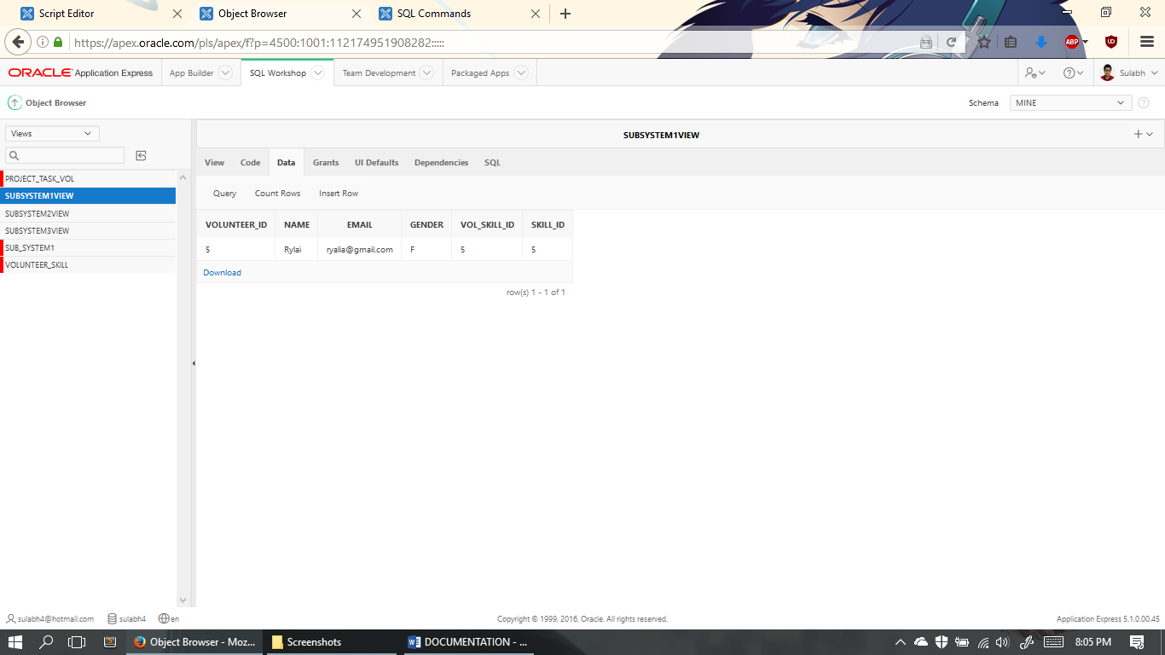

Subsystem1View has only these listed data.

1. Subsystem2View Table

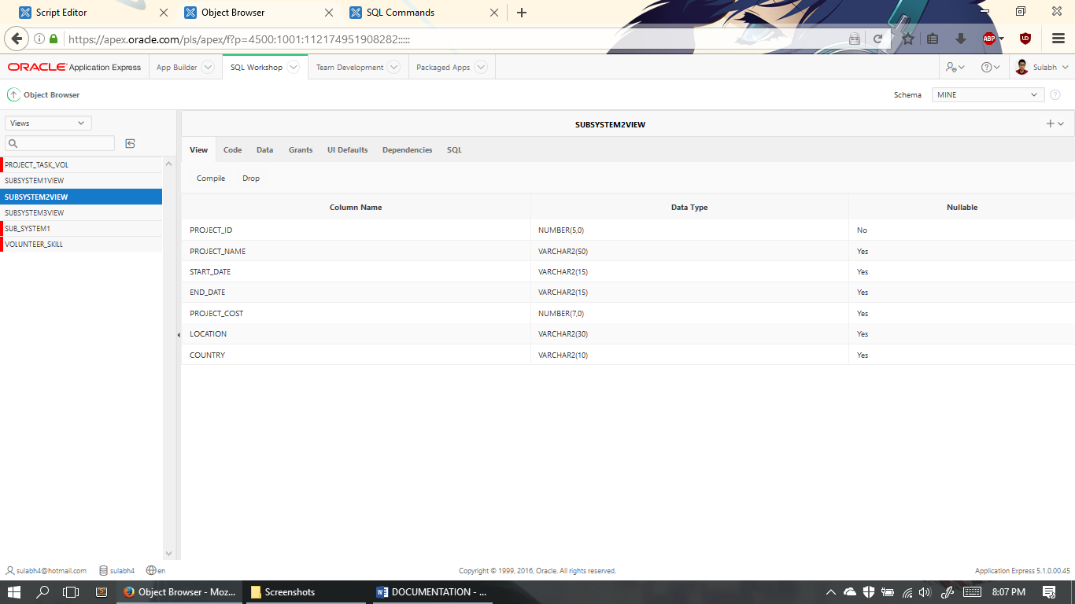

Subsystem2View Table takes project_id, project_name, strat_date, end_date, project_cost, location & country from tables volunteer & vol_skill from project and project_location

1. Subsystem2View SQL

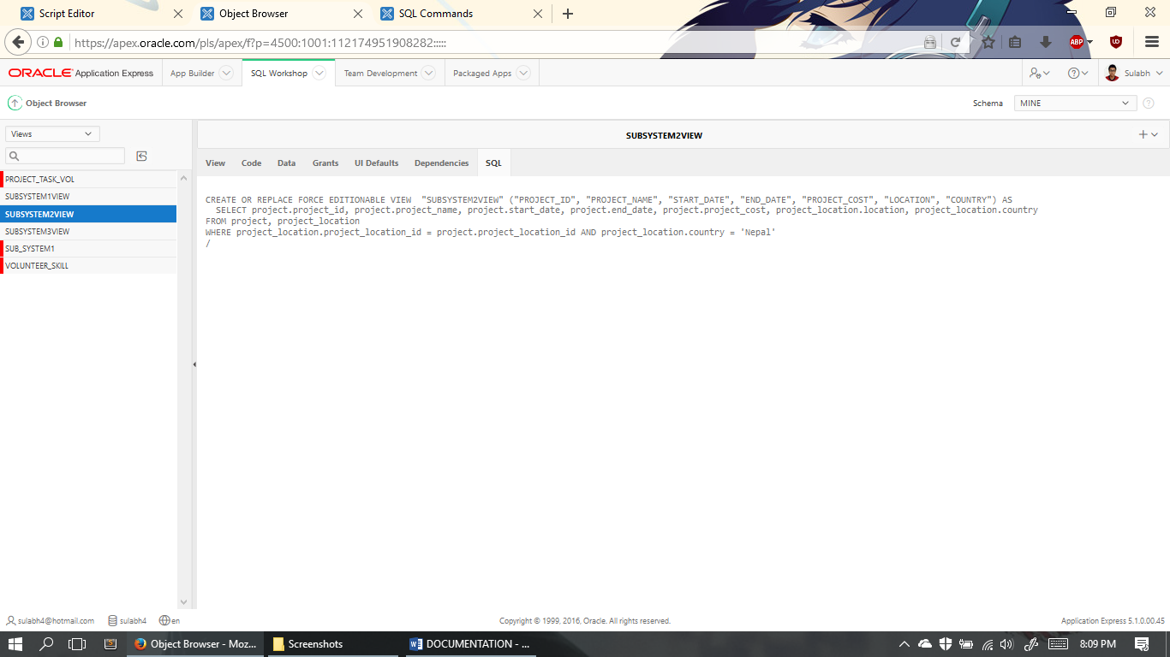

Subsystem2View SQL consists of project_id, project_name, strat_date, end_date, project_cost, location & country from tables volunteer & vol_skill from project and project_location

1. Subsystem2View Data

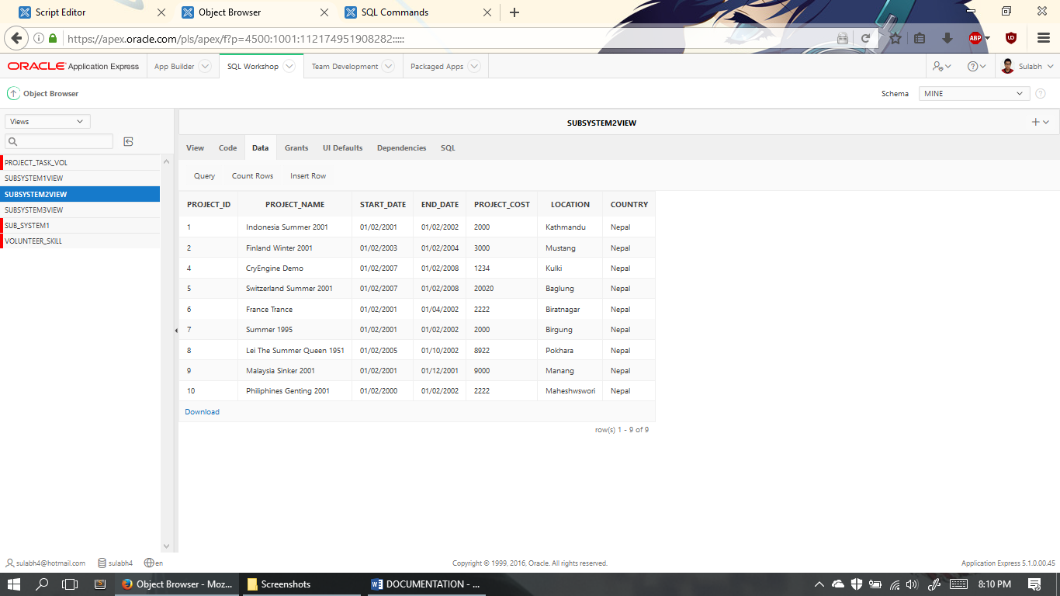

Subsystem2View has these data listed.

1. Subsystem3View Table

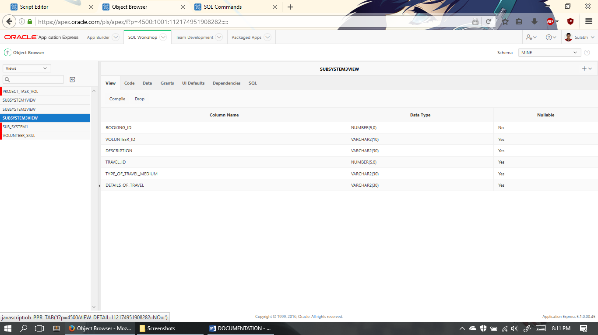

Subsystem3View Table takes booking_id, volunteer_id, description, travel_id, types_of_travel_medium, details_of_travel from travel_booking & travel_option.

1. Subsystem3View SQL

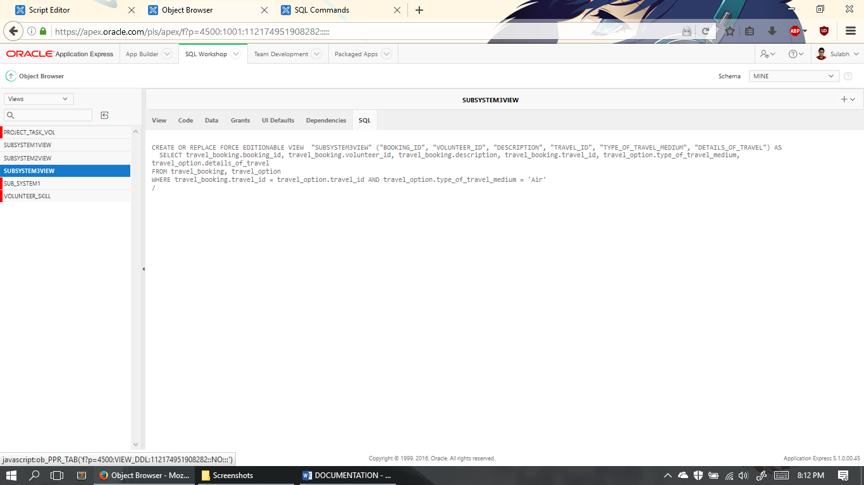

Subsystem3View SQL consists of booking_id, volunteer_id, description, travel_id, types_of_travel_medium, details_of_travel from travel_booking & travel_option.

1. Subsystem3View Data

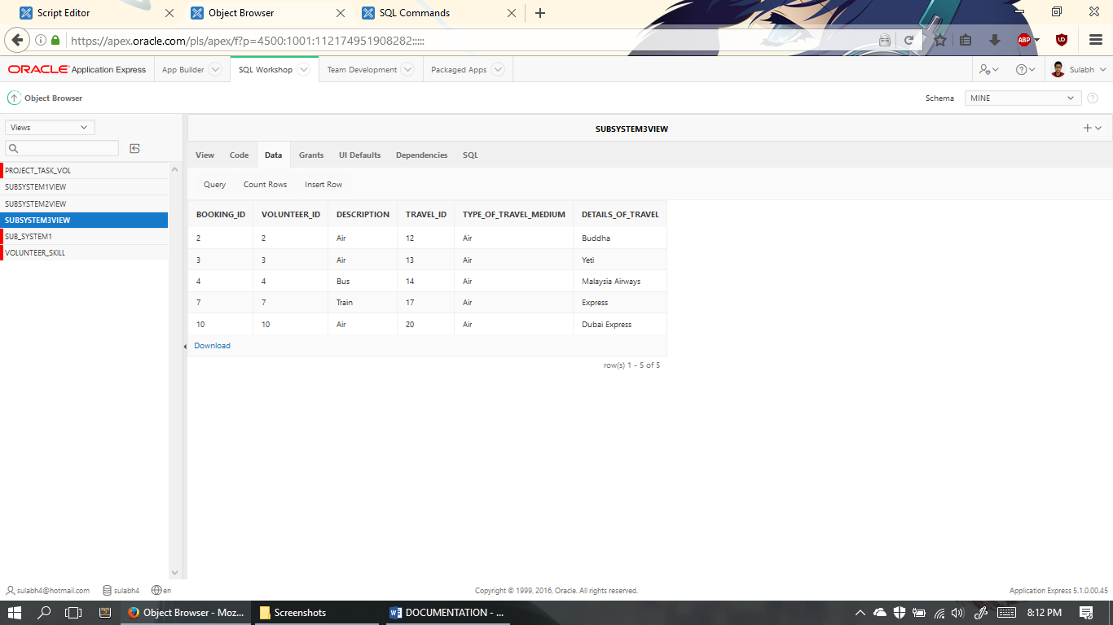

Subsystem3View Data consists of these data.

# TASK 2: Implement 3 suitable SQL statements

1. FirstView

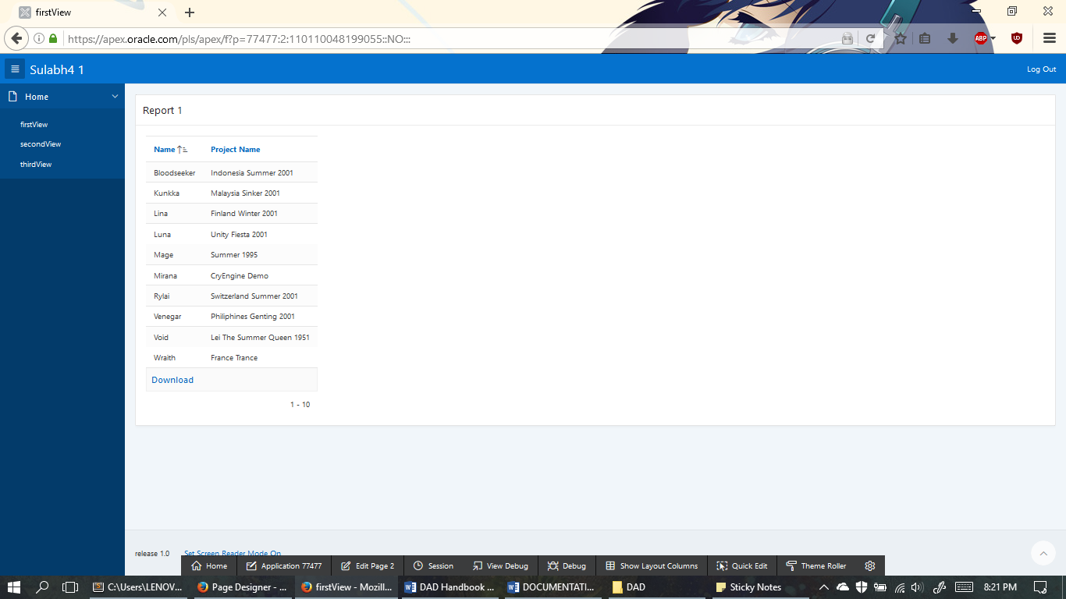

SQL Code:

SELECT volunteer.name, project.project_name

FROM volunteer

INNER JOIN travel_booking

ON volunteer.volunteer_id = travel_booking.volunteer_id

INNER JOIN travel_option

ON travel_booking.travel_id = travel_option.travel_id

INNER JOIN project_location

ON travel_option.project_location_id = project_location.project_location_id

INNER JOIN project

ON project_location.project_location_id = project.project_location_id;

1. Second View

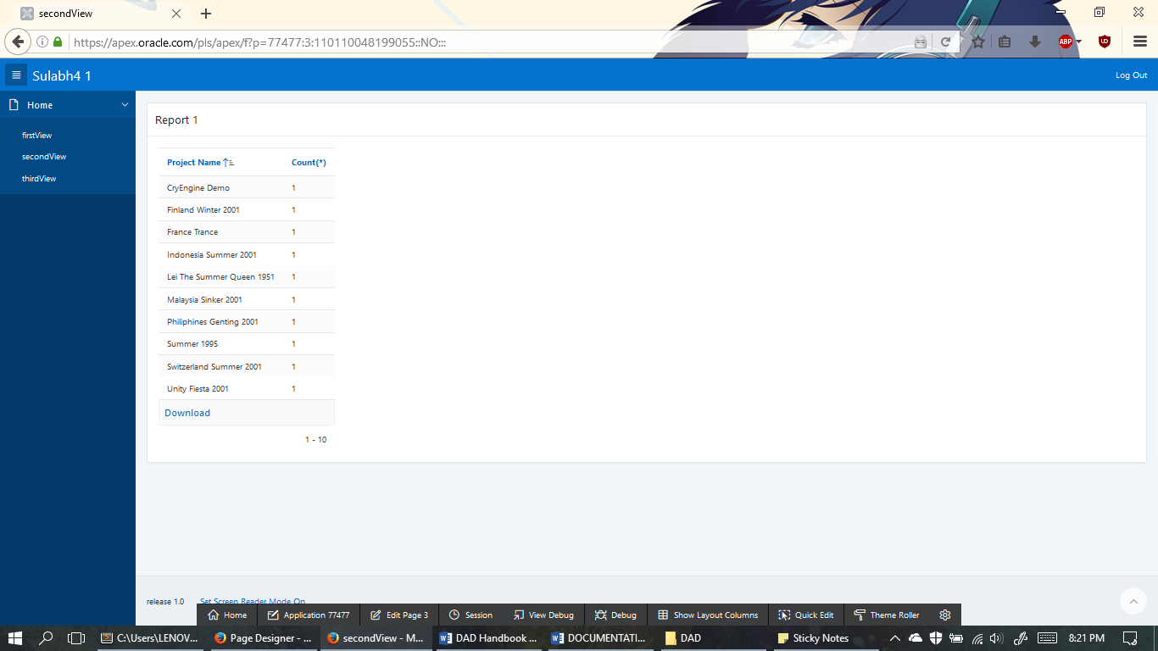

SQL Code:

SELECT project.project_name, count(*)

FROM volunteer

INNER JOIN travel_booking

ON volunteer.volunteer_id = travel_booking.volunteer_id

INNER JOIN travel_option

ON travel_booking.travel_id = travel_option.travel_id

INNER JOIN project_location

ON travel_option.project_location_id = project_location.project_location_id

INNER JOIN project

ON project_location.project_location_id = project.project_location_id

GROUP BY project_name;

1. Third View

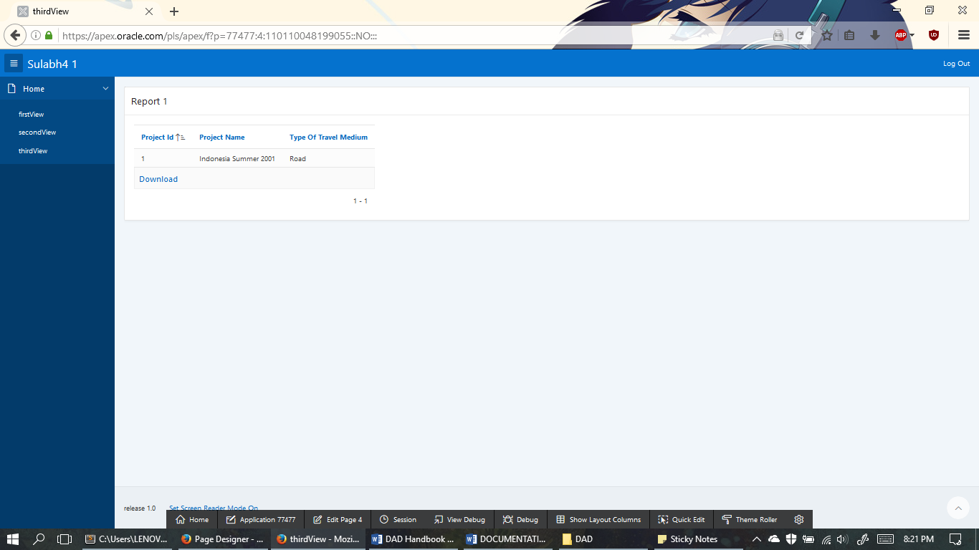

SQL Code:

SELECT project.project_id, project.project_name, travel_option.type_of_travel_medium

FROM project

INNER JOIN project_location

ON project.project_location_id = project_location.project_location_id

INNER JOIN travel_option

ON project_location.project_location_id = travel_option.project_location_id

WHERE project.project_name = 'Indonesia Summer 2001';

# TASK 3: Implement 2 triggers as procedural constraints

1. Trigger101

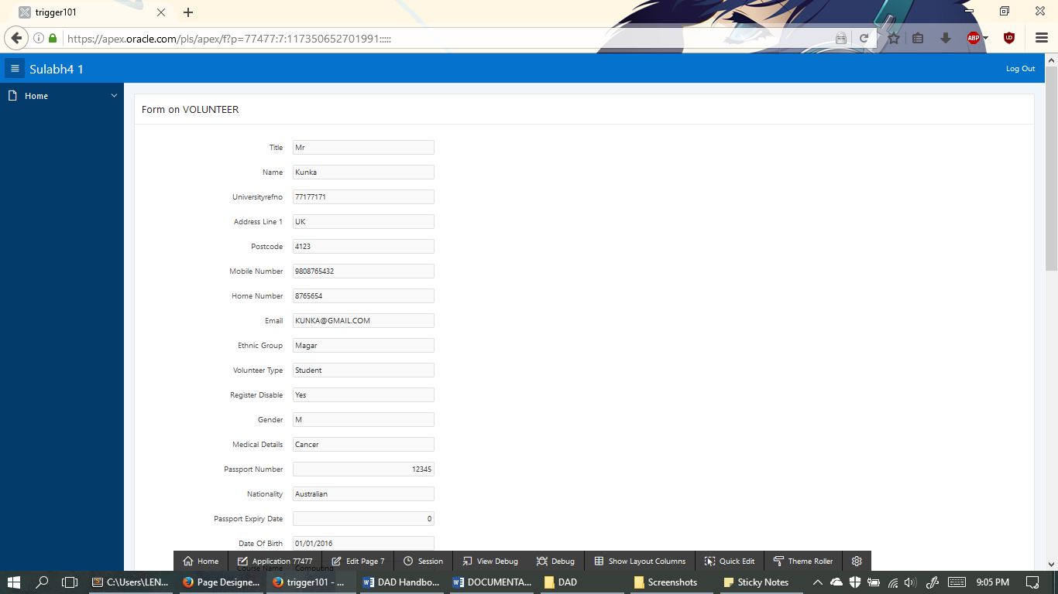

This is the form of the volunteer

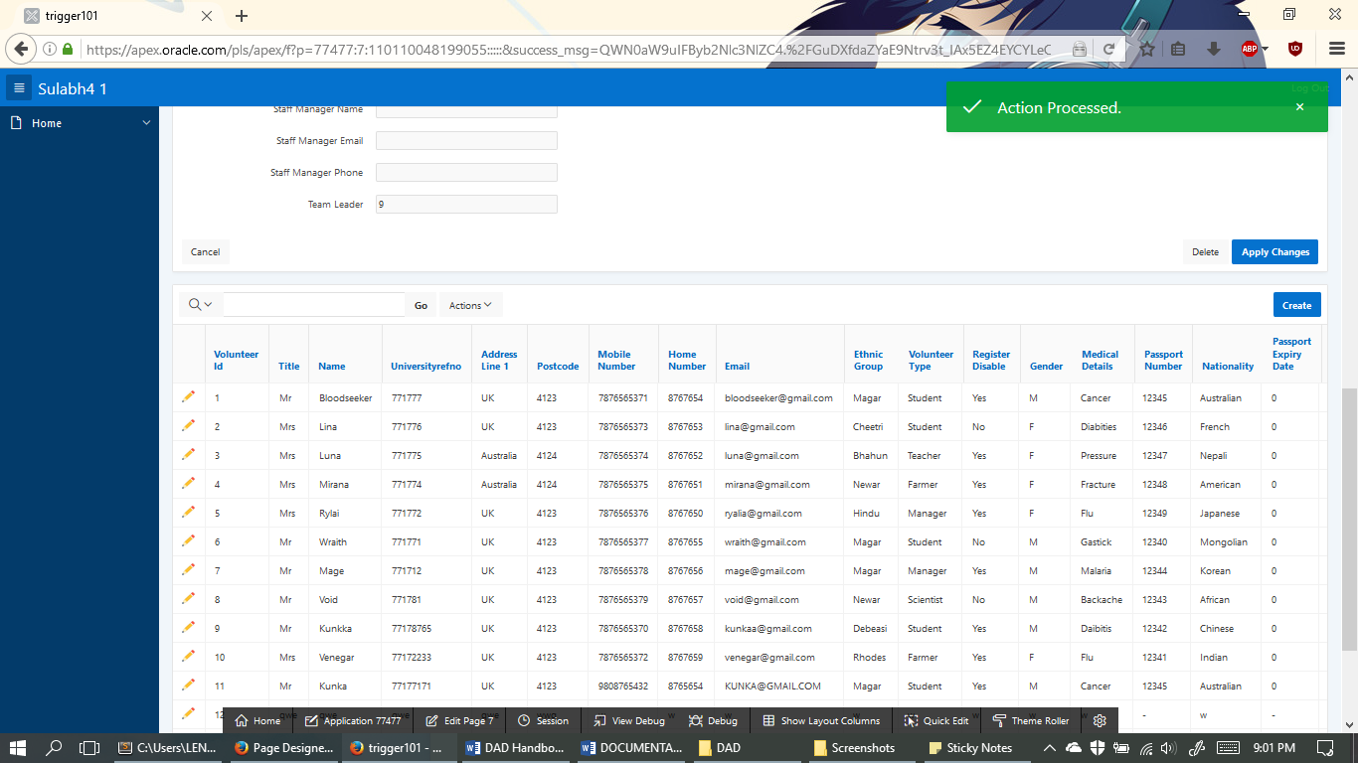

Data formed on Table via trigger

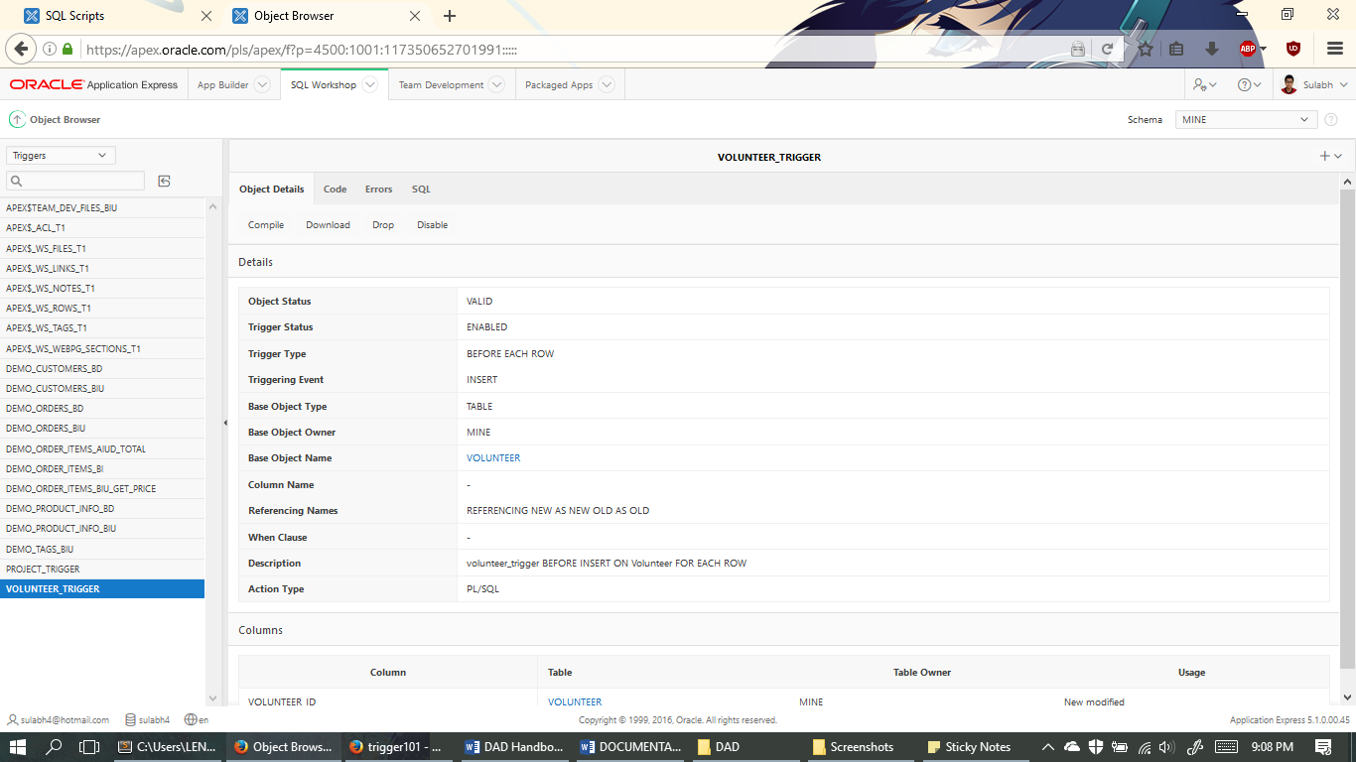

Status of Volunteer’s Trigger

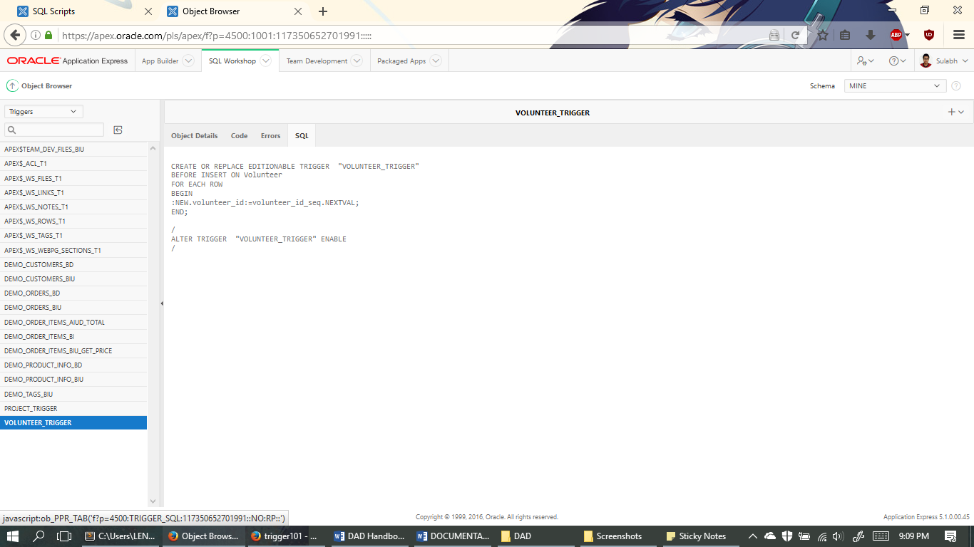

SQL Code of Volunteer’s Trigger

1. Trigger102

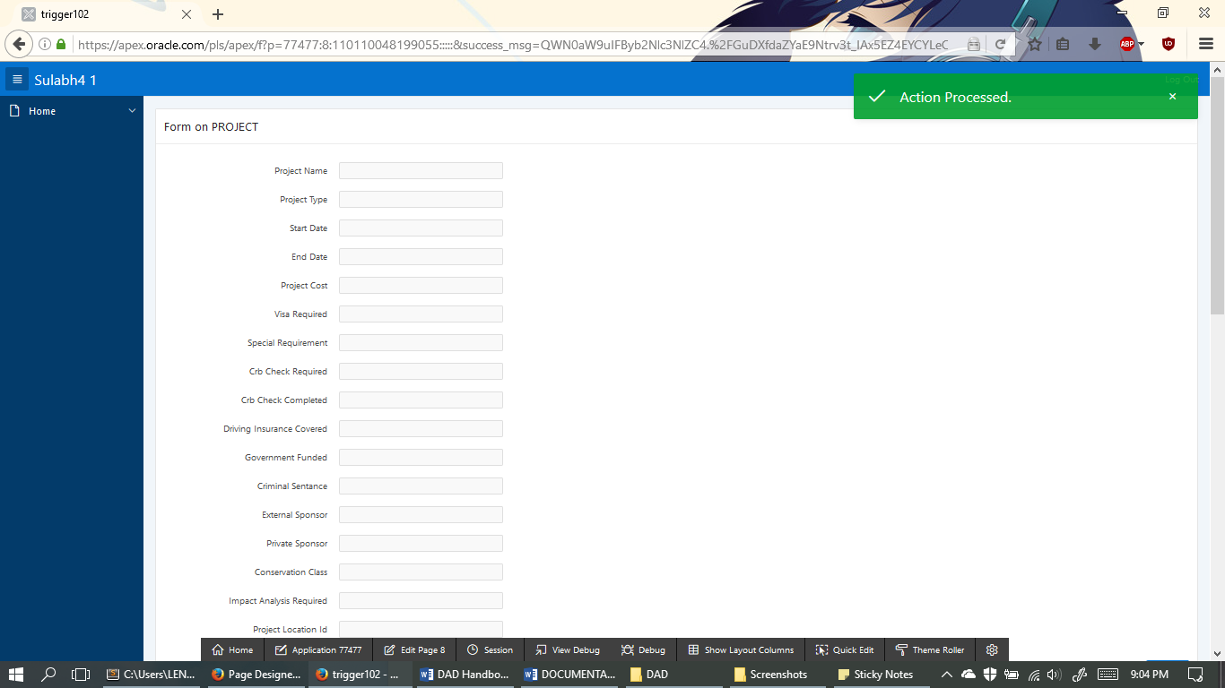

This is the form of the Project Table

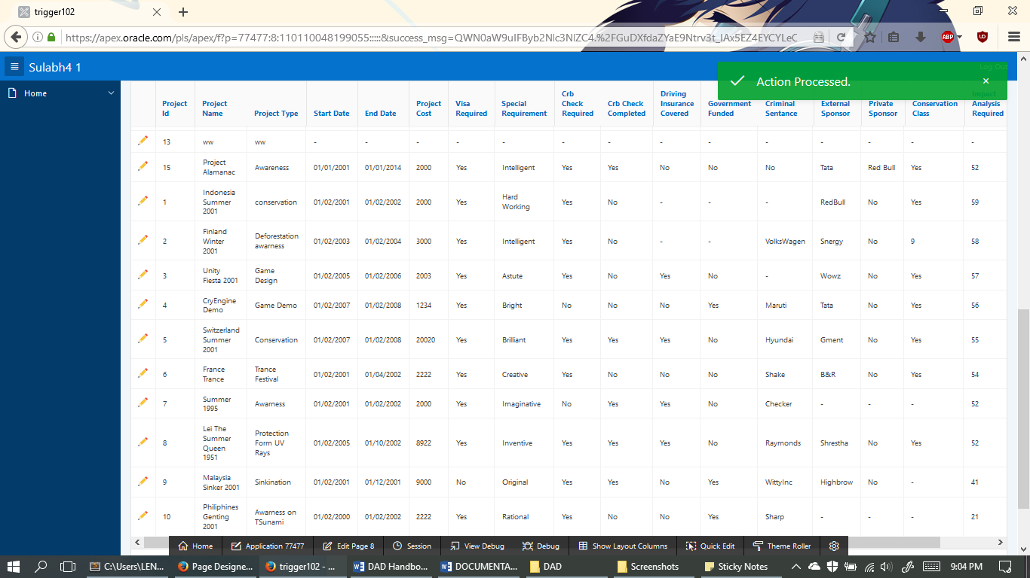

This is the data entered on that form

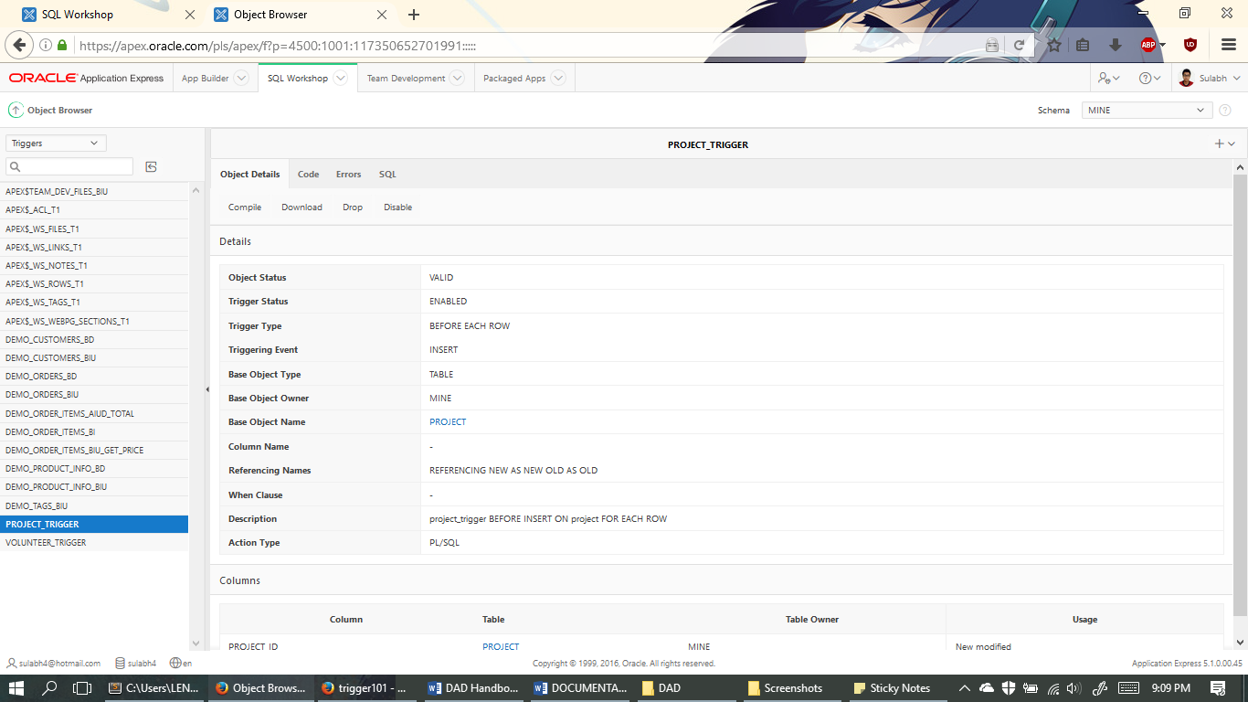

Project’s Trigger Status

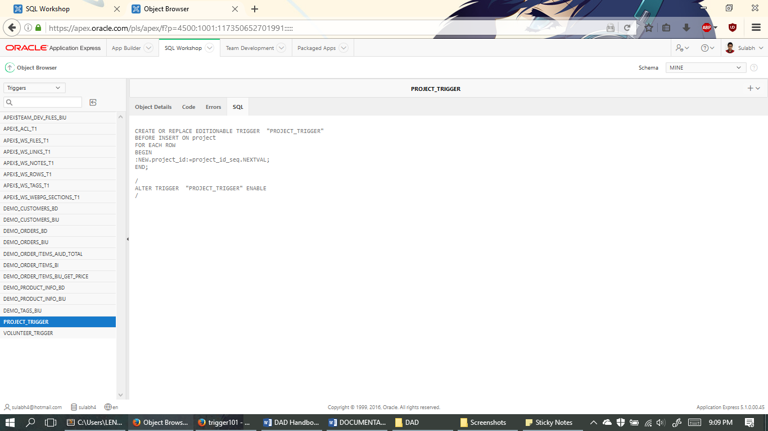

Project’s Trigger SQL Code

# TASK 4: Built appropriate APEX forms/pages

1. Volunteer Table

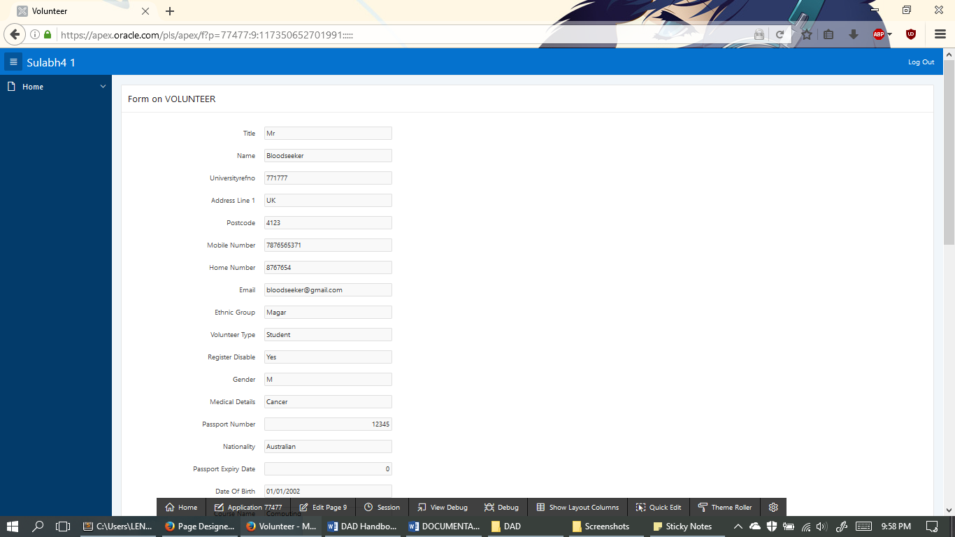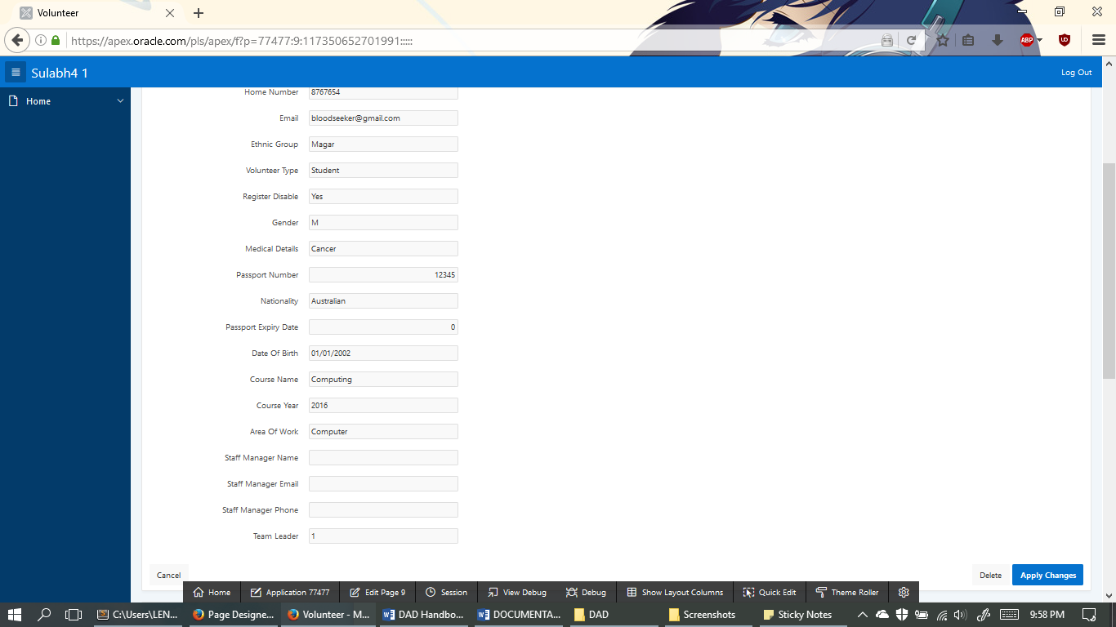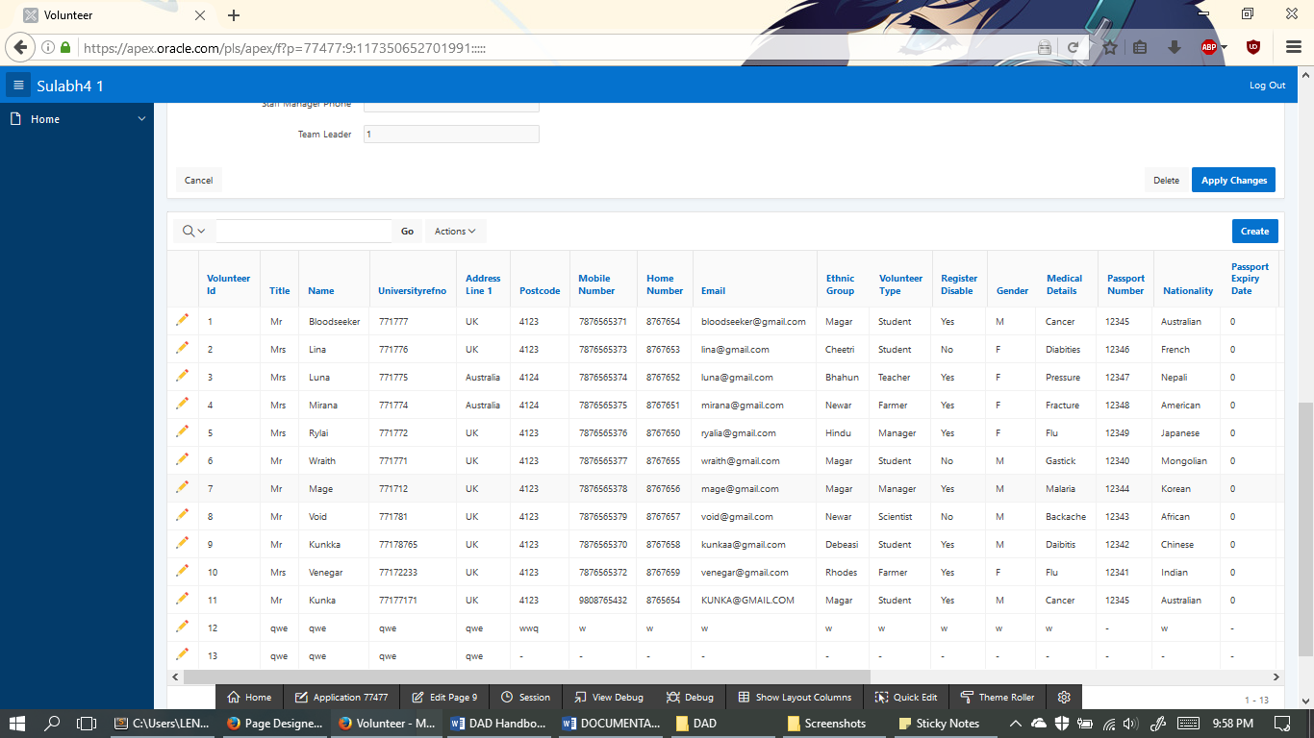

These table contains places for insert, edit and delete

1. Skill Table

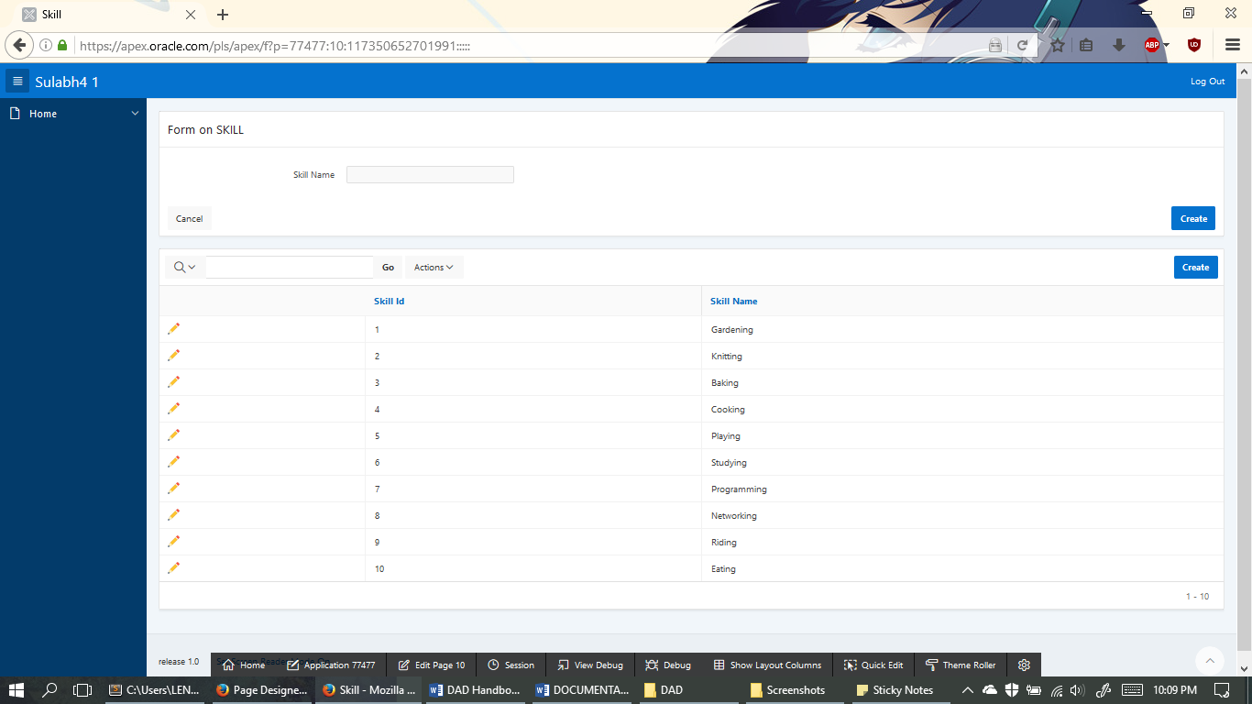

These table contains places for insert, edit and delete

1. Vol_Skill

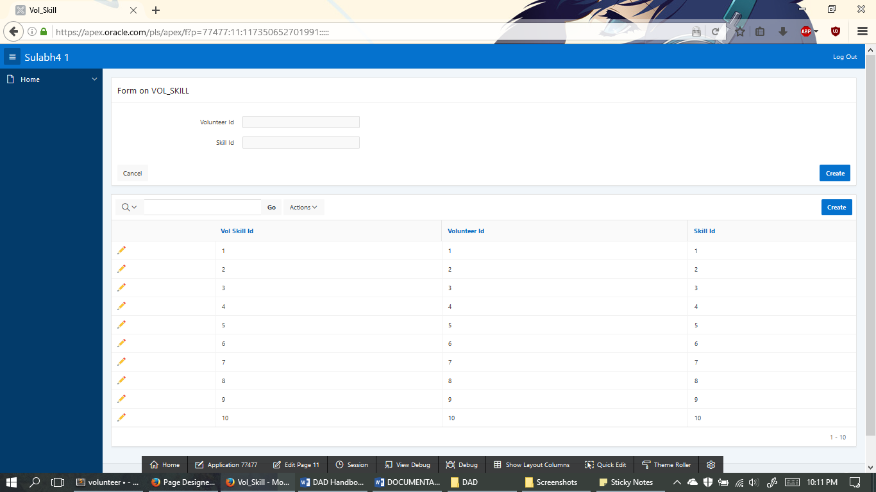

These table contains places for insert, edit and delete

1. Project_Location

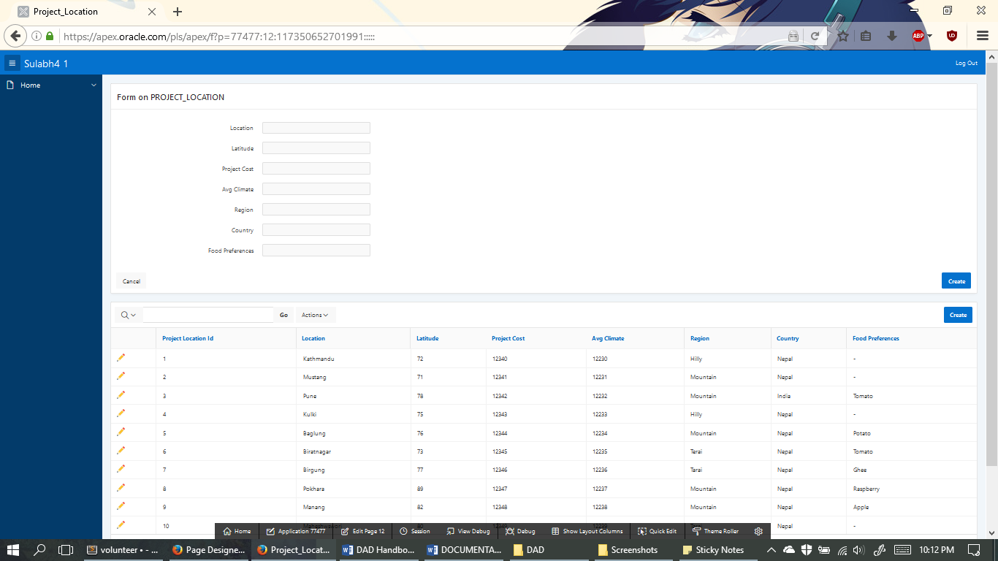

These table contains places for insert, edit and delete

1. Project

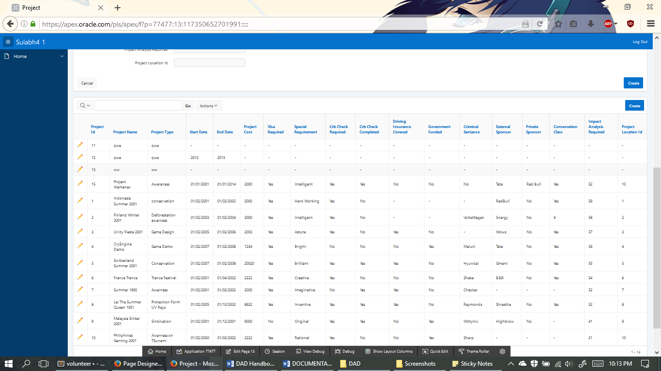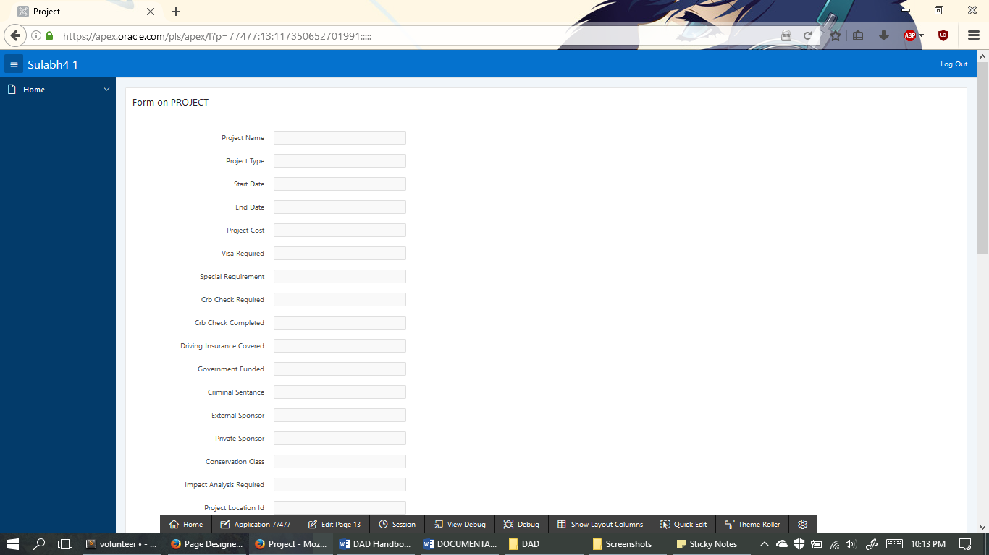

These table contains places for insert, edit and delete

1. Task

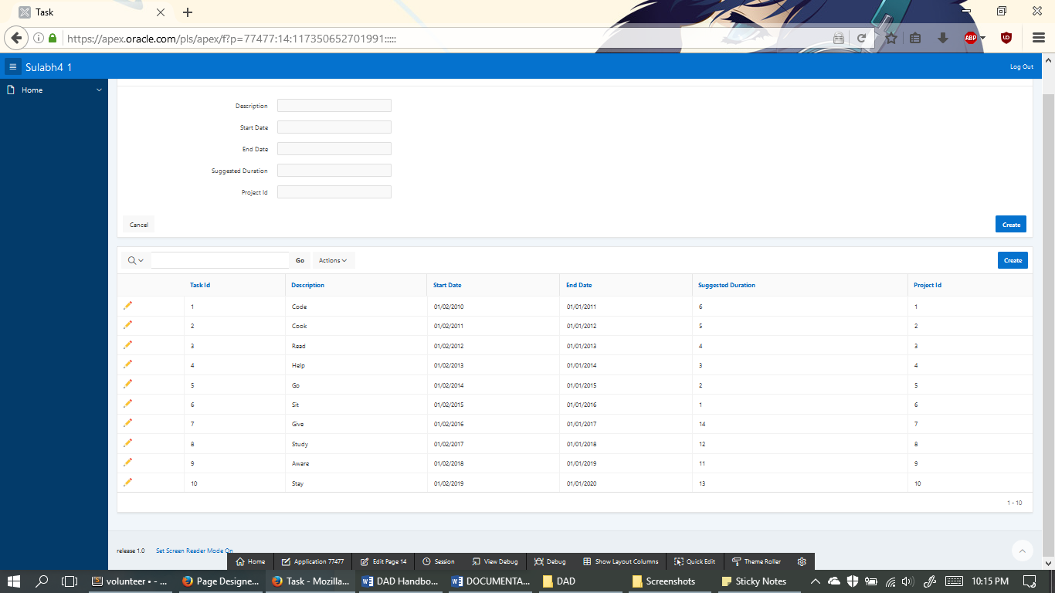

These table contains places for insert, edit and delete

1. Skill_Task

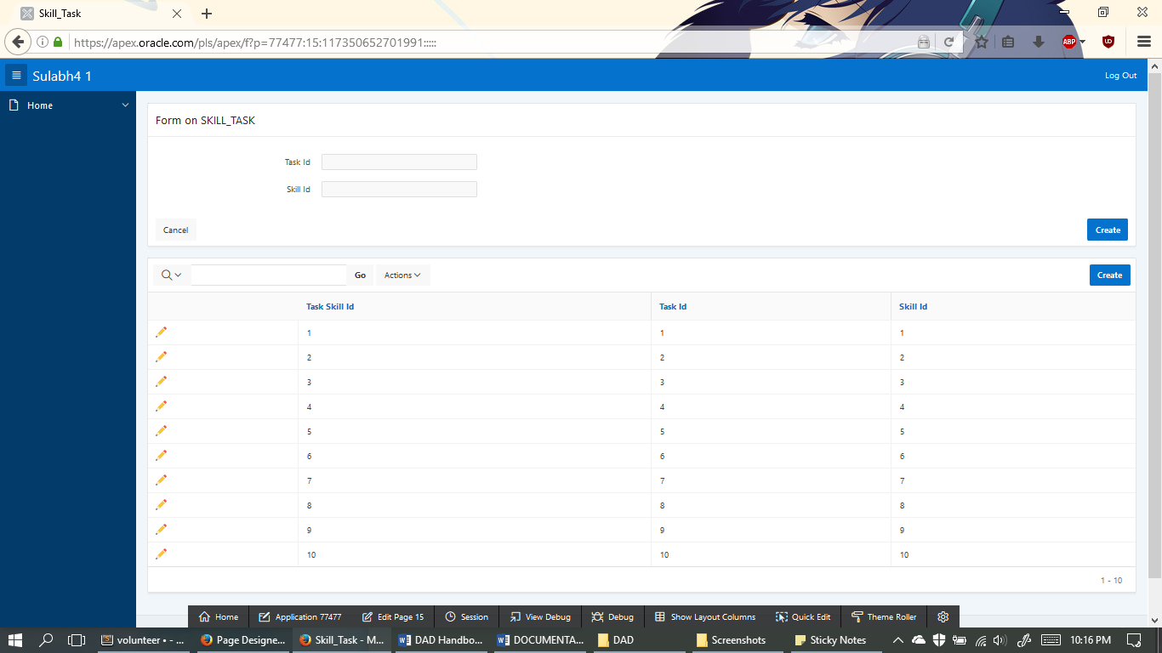

These table contains places for insert, edit and delete

1. Task_Activity

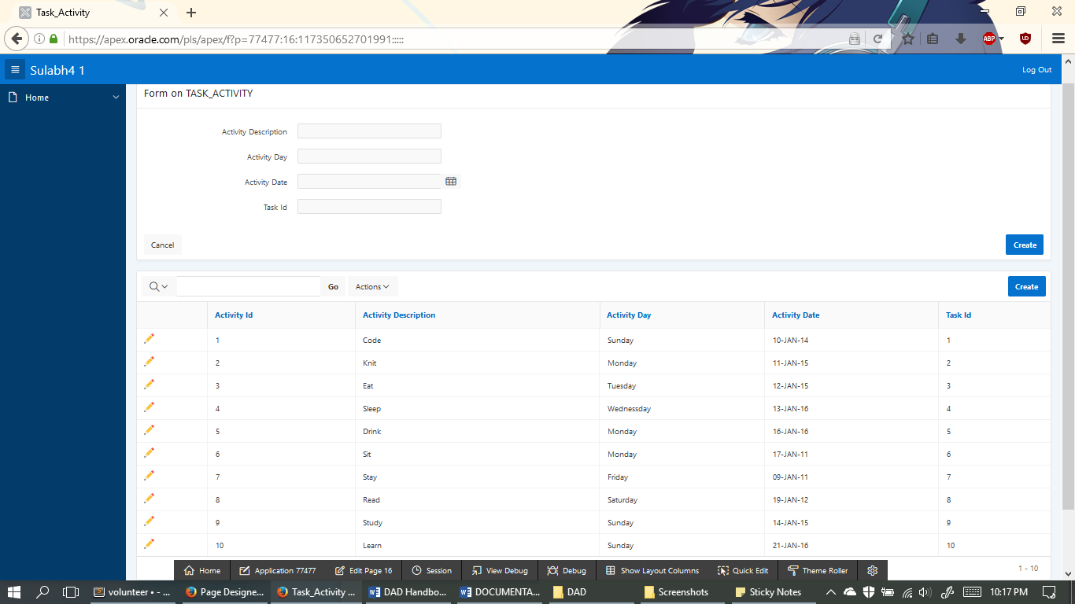

These table contains places for insert, edit and delete

1. Project_Contact

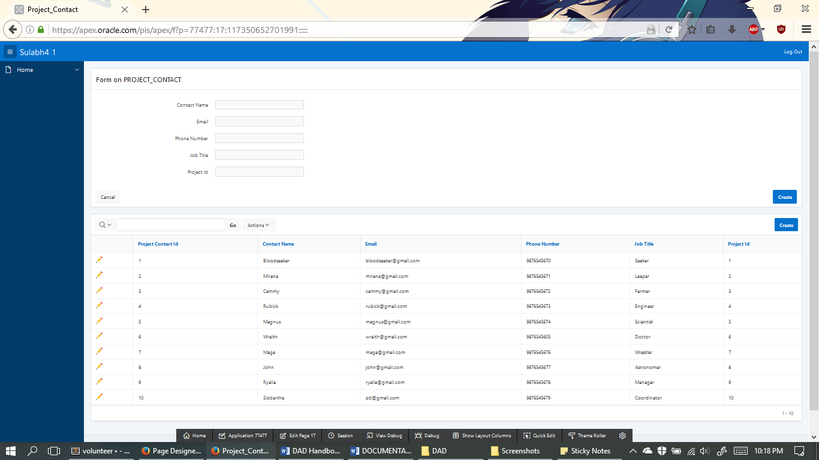

These table contains places for insert, edit and delete

1. Travel_Option

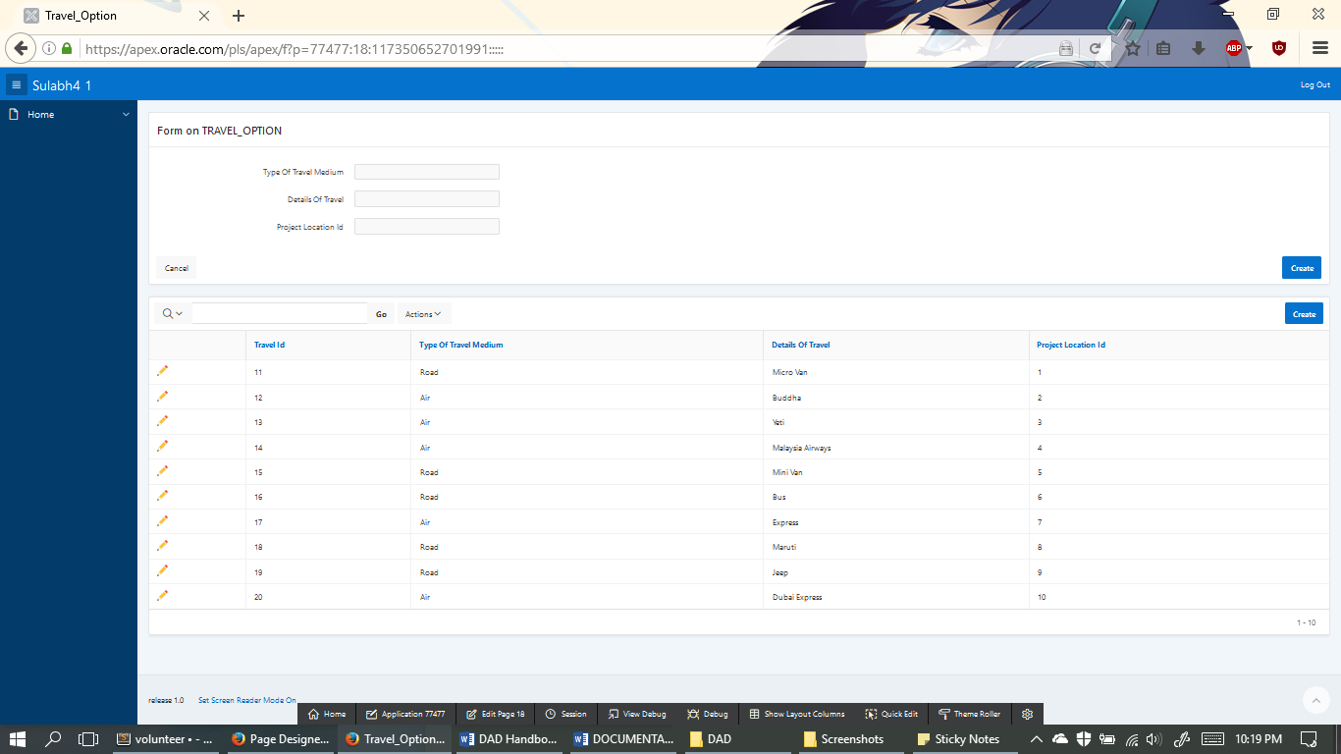

These table contains places for insert, edit and delete

1. Travel_Booking

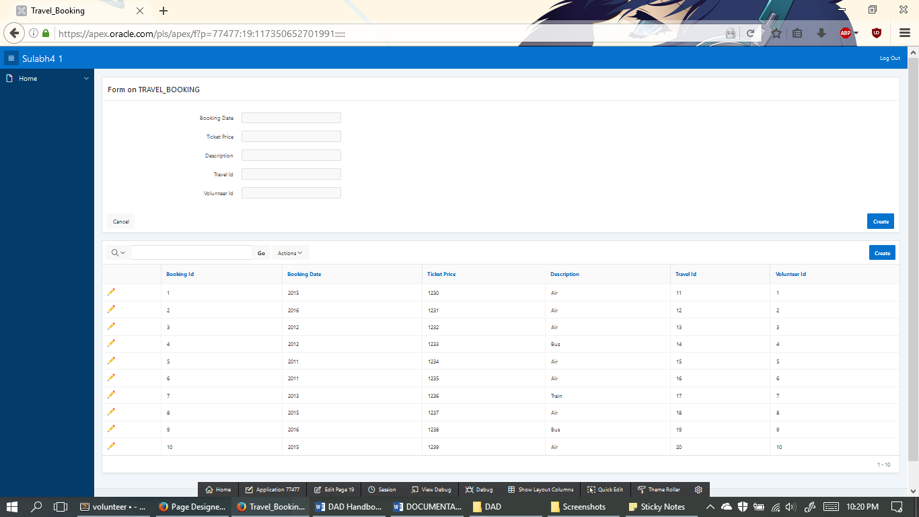

These table contains places for insert, edit and delete

1. Chart on Volunteer’s Table

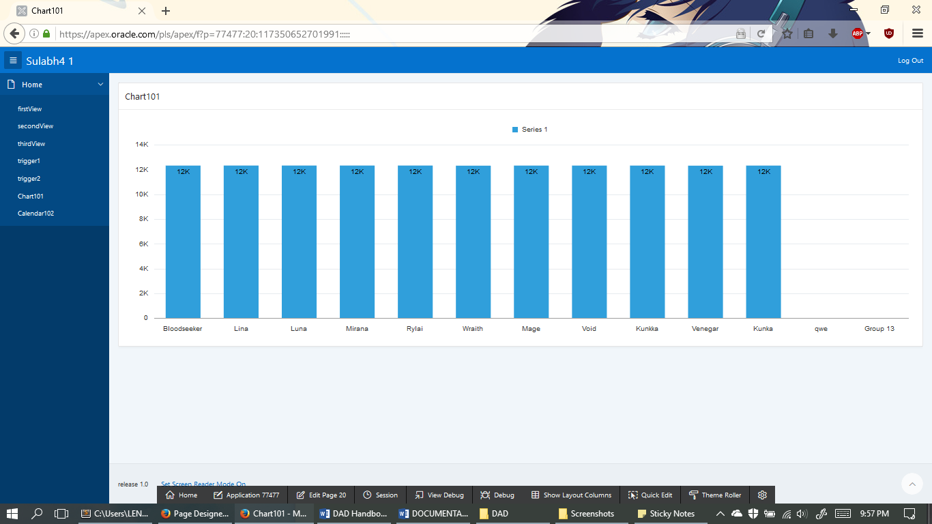

1. Calendar on Task_Activities Date

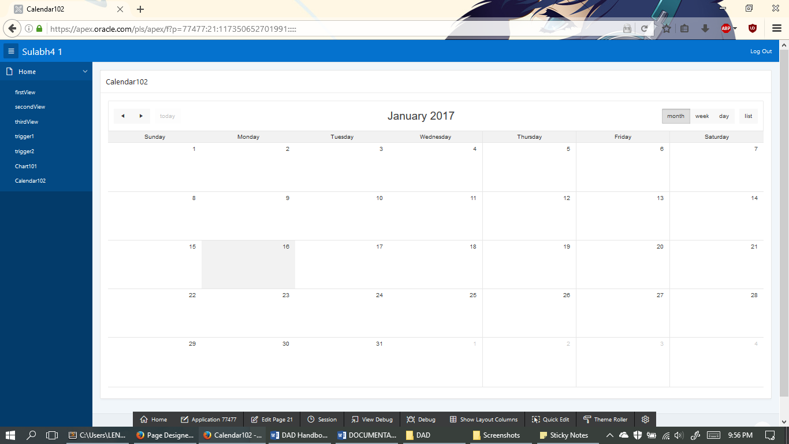

1. Master Detail on Volunteer

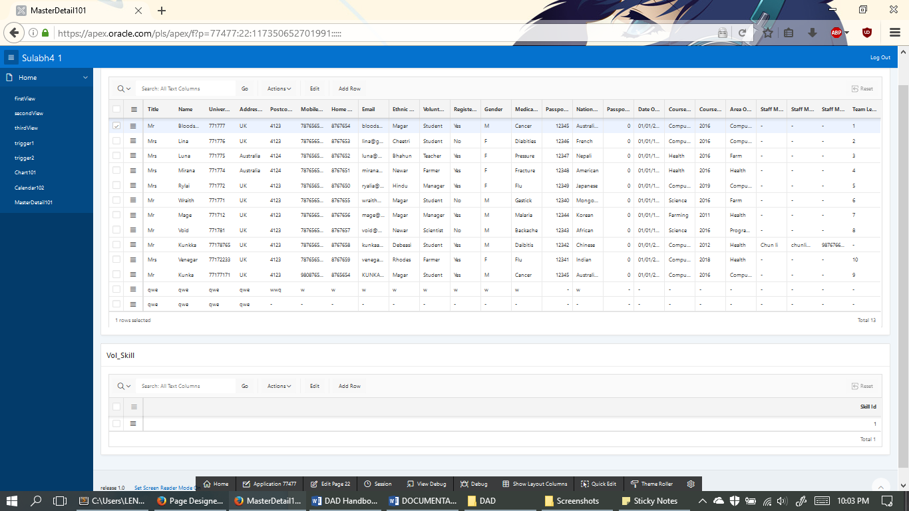

1. Master Detail on Project

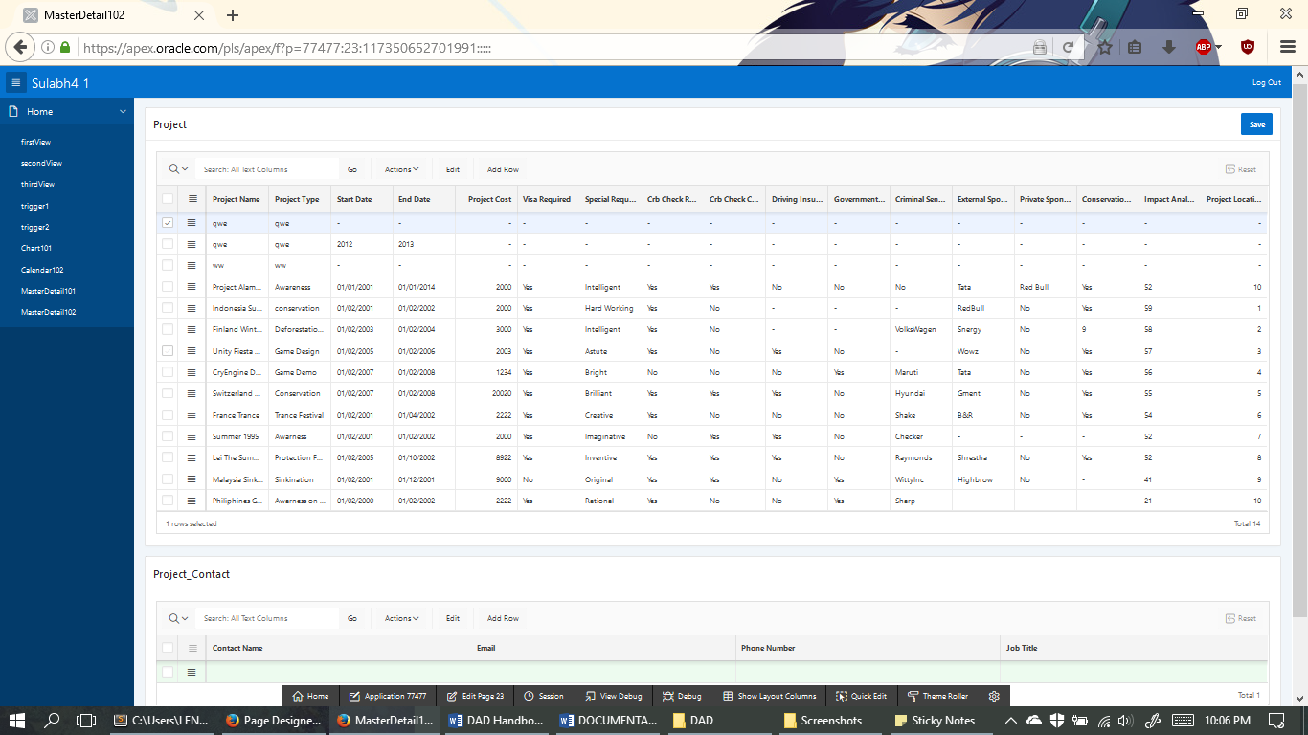

# TASK 5: Create a User Guide for one of your Apex Pages

(Master Details on Project)

(The Highlighted RED ones are the actual data changes on this section)

This part of the application provides functionality to:

* View all the project details.
* Update project name.
* Update the project_contact data.
* Delete project_contact data.
* Insert new project_contact data.
* Deleting a Project data

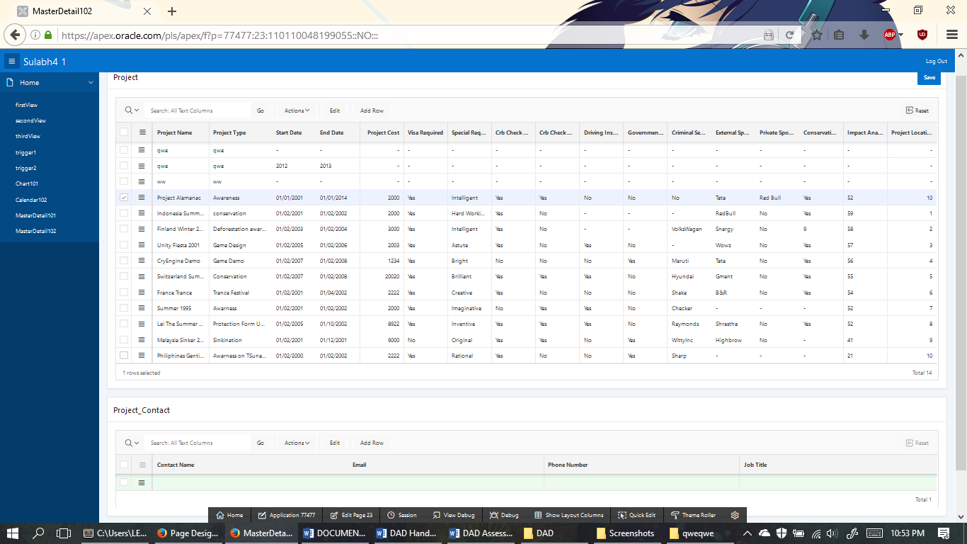

This is the project details which can be viewed o this master details page

For the next step, we are going to edit the name of project_Almanac to project_Omniknight

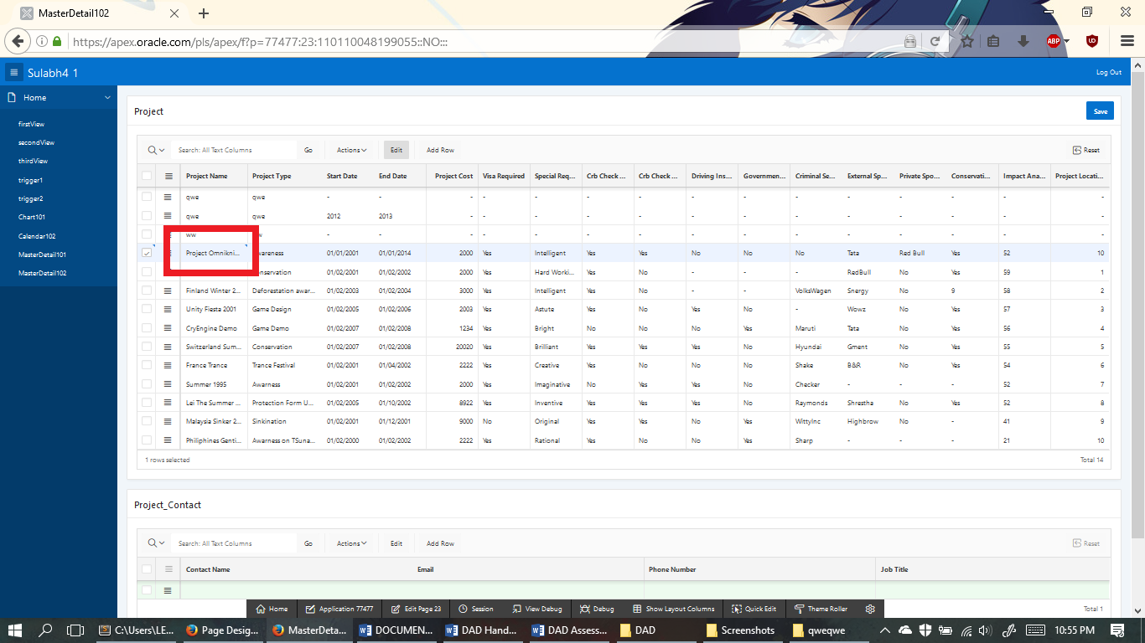

As you can see that we have changed the project_name in the master_details page.

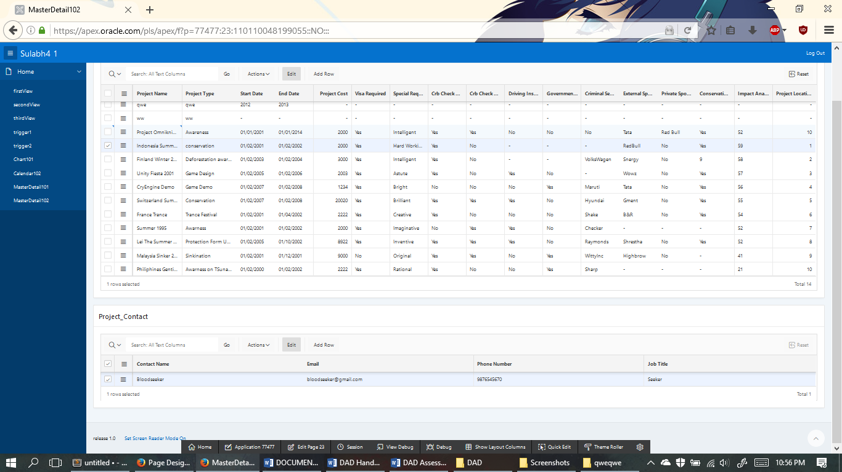

This is the masterDetails page where we can see the link between the project and project_contact. There is only one link between them and now we are going to change Bloodseeker to Omniknight.

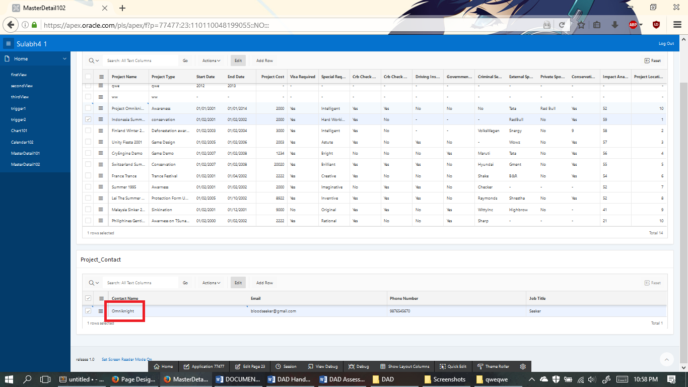

As you can see that we have changed the name fromm Bloodseeker to Omniknight. Now in the next step, we are going to delete the project_contact details complete from Indonesia Summer 2001 Project_name

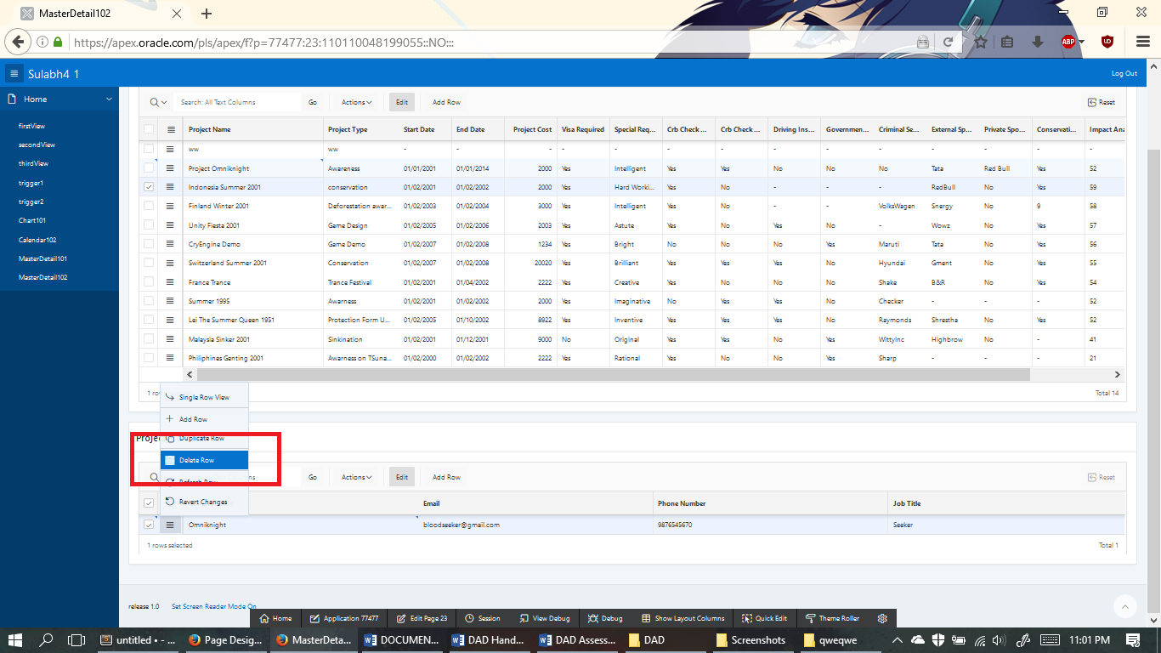

We can now delete the row safely

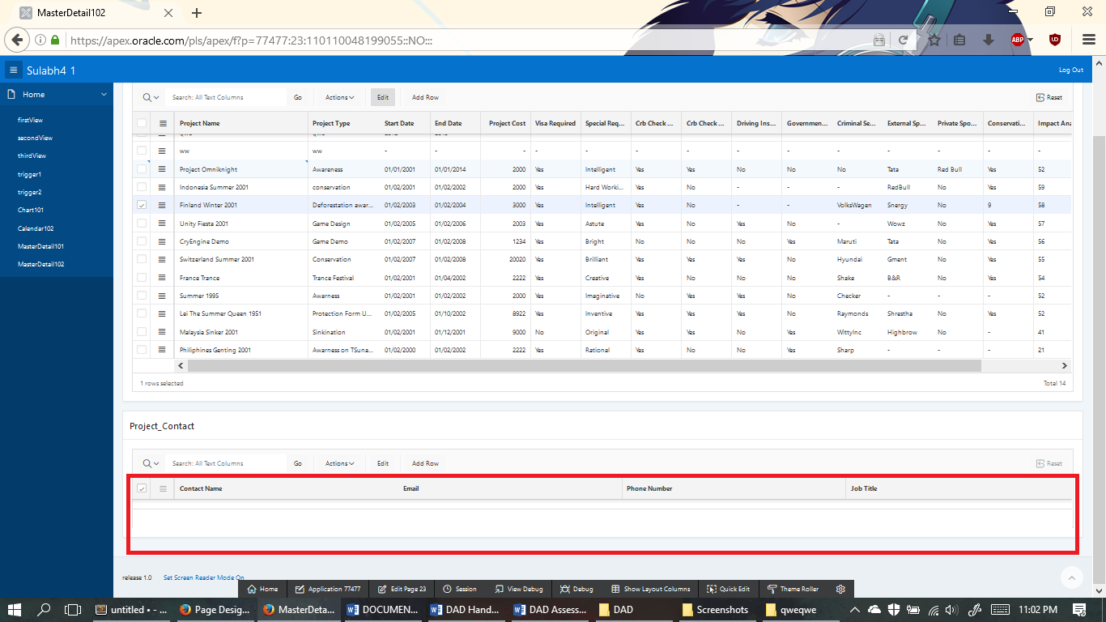

The data has been deleted. Now at last, we add data to the project_contact.

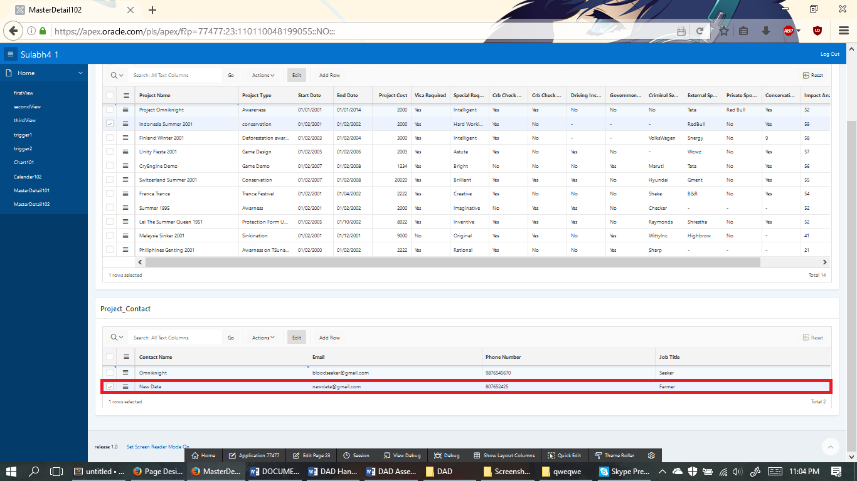

As you can see that we have inserted a new data on Project_Contact called NewData with email as [newdata@gmail.com](mailto:newdata@gmail.com) and etc etc.

Now at last, we need to delete a data form the project table.

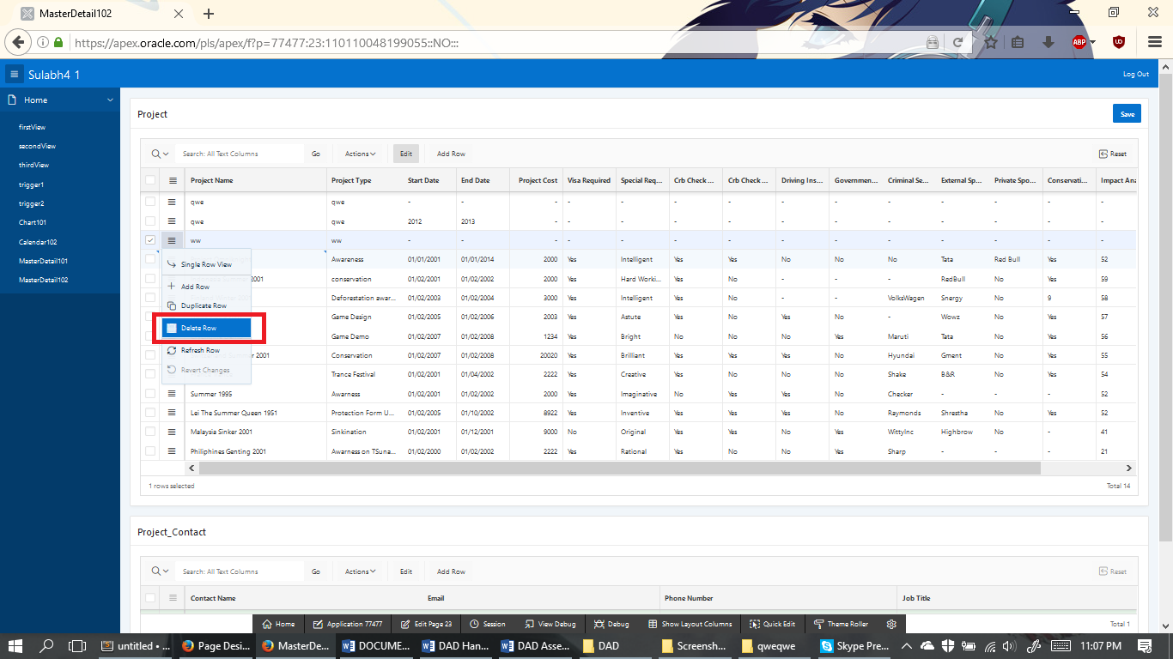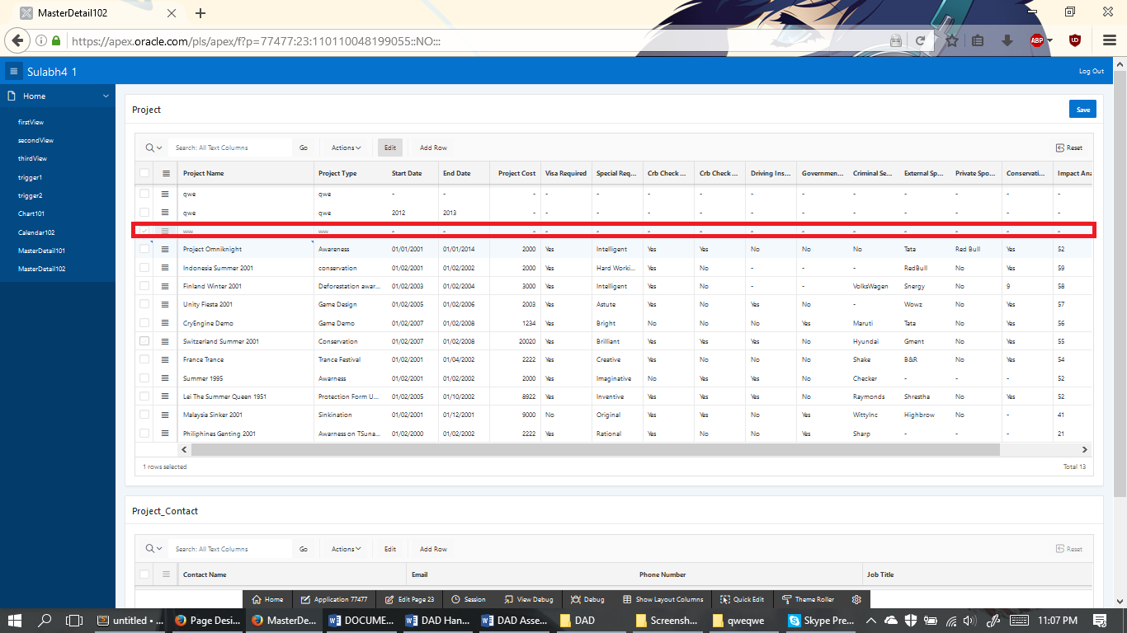

We have successfully delete data called “ww” from the masterDetails table

Appendix 1

1. For each of the SDLC stages (conceptual, logical, physical, implementation, testing) discuss, where appropriate, what are the ‘inputs’, and what are the outputs, (i.e. what are produced at the end). [ 2 Marks]

* Inputs are those which are got from the keyboard or mouse. Database inputs are got from the keyboard and through some process in the DBMS and a table, according to the user’s desired, are created which are the outputs of our program.

1. What steps did we use in class to verify the outcomes of each stage, and how effective were they? [2 Mark]

* Triggers and sequence are used. Sequence are those which are auto-incremented in the table’s database where’s triggers can be fired when we insert or update or delete.

1. List two strengths and two weaknesses of your prototype database in terms of its ability to meet the requirements? [1 Marks]

* My strengths are the master details and the flow of the program. My two weakness are the calendar and the bar graph

Appendix 2

/* Drop */

DROP TABLE volunteer CASCADE CONSTRAINTS;

DROP TABLE skill CASCADE CONSTRAINTS;

DROP TABLE vol_skill CASCADE CONSTRAINTS;

DROP TABLE project CASCADE CONSTRAINTS;

DROP TABLE task CASCADE CONSTRAINTS;

DROP TABLE skill_task CASCADE CONSTRAINTS;

DROP TABLE task_activity CASCADE CONSTRAINTS;

DROP TABLE project_contact CASCADE CONSTRAINTS;

DROP TABLE travel_booking CASCADE CONSTRAINTS;

DROP TABLE travel_option CASCADE CONSTRAINTS;

DROP TABLE project_location CASCADE CONSTRAINTS;

/* Create */

CREATE TABLE volunteer(

volunteer_id VARCHAR(10),

title VARCHAR2(5),

name VARCHAR2(30),

universityRefNo VARCHAR2(10),

address_line_1 VARCHAR2(12),

postcode VARCHAR2(12),

mobile_number VARCHAR2(12),

home_number VARCHAR2(12),

email VARCHAR2(30),

ethnic_group VARCHAR2(10),

volunteer_type VARCHAR2(10),

register_disable VARCHAR2(3),

gender VARCHAR2(1),

medical_details VARCHAR2(20),

passport_number NUMBER(10),

nationality VARCHAR2(10),

passport_expiry_date NUMBER(10),

date_of_birth VARCHAR2(10),

course_name VARCHAR2(20),

course_year VARCHAR2(10),

area_of_work VARCHAR2(15),

staff_manager_name VARCHAR2(20),

staff_manager_email VARCHAR2(20),

staff_manager_phone VARCHAR2(12),

PRIMARY KEY (volunteer_id),

team_leader VARCHAR(10) REFERENCES volunteer(volunteer_id)

);

CREATE TABLE skill(

skill_id NUMBER(5),

skill_name VARCHAR2(35),

PRIMARY KEY (skill_id)

);

CREATE TABLE vol_skill(

vol_skill_id NUMBER(5),

volunteer_id VARCHAR(10) REFERENCES volunteer(volunteer_id),

skill_id NUMBER(5) REFERENCES skill(skill_id),

PRIMARY KEY (vol_skill_id)

);

CREATE TABLE project_location(

project_location_id NUMBER(5),

location VARCHAR2(30),

latitude VARCHAR2(2),

project_cost NUMBER(10),

avg_climate NUMBER(10),

region VARCHAR2(10),

country VARCHAR2(10),

food_preferences VARCHAR2(20),

PRIMARY KEY (project_location_id)

);

CREATE TABLE project(

project_id NUMBER(5),

project_name VARCHAR2(50),

project_type VARCHAR2(50),

start_date VARCHAR2(15),

end_date VARCHAR2(15),

project_cost NUMBER(7),

visa_required VARCHAR2(3),

special_requirement VARCHAR2(50),

CRB_check_required VARCHAR2(3),

CRB_check_completed VARCHAR2(15),

driving_insurance_covered VARCHAR2(15),

government_funded VARCHAR2(15),

criminal_sentance VARCHAR2(50),

external_sponsor VARCHAR2(15),

private_sponsor VARCHAR2(15),

conservation_class VARCHAR2(3),

impact_analysis_required VARCHAR2(3),

project_location_id NUMBER(5) REFERENCES project_location(project_location_id),

PRIMARY KEY (project_id)

);

CREATE TABLE task(

task_id NUMBER(5),

description VARCHAR2(35),

start_date VARCHAR2(15),

end_date VARCHAR2(15),

suggested_duration VARCHAR2(15),

PRIMARY KEY (task_id),

project_id NUMBER(5) REFERENCES project(project_id)

);

CREATE TABLE skill_task(

task_skill_id NUMBER(5),

task_id NUMBER(5) REFERENCES task(task_id),

skill_id NUMBER(5) REFERENCES skill(skill_id),

PRIMARY KEY (task_skill_id)

);

CREATE TABLE task_activity(

activity_id NUMBER(5),

activity_description VARCHAR2(20),

activity_day VARCHAR2(10),

activity_date DATE,

task_id NUMBER(5) REFERENCES task(task_id),

PRIMARY KEY(activity_id)

);

CREATE TABLE project_contact(

project_contact_id NUMBER(5),

contact_name VARCHAR2(20),

email VARCHAR2(30),

phone_number VARCHAR2(20),

job_title VARCHAR2(20),

project_id NUMBER(5) REFERENCES project(project_id),

PRIMARY KEY (project_contact_id)

);

CREATE TABLE travel_option(

travel_id NUMBER(5),

type_of_travel_medium VARCHAR2(30),

details_of_travel VARCHAR2(30),

project_location_id NUMBER(5),

PRIMARY KEY (travel_id),

FOREIGN KEY (project_location_id)

REFERENCES project_location(project_location_id)

);

CREATE TABLE travel_booking(

booking_id NUMBER(5),

booking_date NUMBER(15),

ticket_price VARCHAR2(20),

description VARCHAR2(30),

travel_id NUMBER(5) REFERENCES travel_option(travel_id),

volunteer_id VARCHAR(10) REFERENCES volunteer(volunteer_id),

PRIMARY KEY (booking_id)

);

/* Sequence */

DROP SEQUENCE volunteer_id_seq;

CREATE SEQUENCE volunteer_id_seq

START WITH 1

INCREMENT BY 1

NOCACHE

NOCYCLE;

DROP SEQUENCE project_contact_id_seq;

CREATE SEQUENCE project_contact_id_seq

START WITH 1

INCREMENT BY 1

NOCACHE

NOCYCLE;

DROP SEQUENCE skill_id_seq;

CREATE SEQUENCE skill_id_seq

START WITH 1

INCREMENT BY 1

NOCACHE

NOCYCLE;

DROP SEQUENCE vol_skill_id_seq;

CREATE SEQUENCE vol_skill_id_seq

START WITH 1

INCREMENT BY 1

NOCACHE

NOCYCLE;

DROP SEQUENCE project_location_seq;

CREATE SEQUENCE project_location_seq

START WITH 1

INCREMENT BY 1

NOCACHE

NOCYCLE;

DROP SEQUENCE project_id_seq;

CREATE SEQUENCE project_id_seq

START WITH 1

INCREMENT BY 1

NOCACHE

NOCYCLE;

DROP SEQUENCE task_id_seq;

CREATE SEQUENCE task_id_seq

START WITH 1

INCREMENT BY 1

NOCACHE

NOCYCLE;

DROP SEQUENCE task_skill_id_seq;

CREATE SEQUENCE task_skill_id_seq

START WITH 1

INCREMENT BY 1

NOCACHE

NOCYCLE;

DROP SEQUENCE travel_id_seq;

CREATE SEQUENCE travel_id_seq

START WITH 1

INCREMENT BY 1

NOCACHE

NOCYCLE;

DROP SEQUENCE booking_id_seq;

CREATE SEQUENCE booking_id_seq

START WITH 1

INCREMENT BY 1

NOCACHE

NOCYCLE;

DROP SEQUENCE activity_id_seq;

CREATE SEQUENCE activity_id_seq

START WITH 1

INCREMENT BY 1

NOCACHE

NOCYCLE;

/* Insert */

INSERT INTO volunteer(volunteer_id, title,

name,

universityRefNo,

address_line_1,

postcode,

mobile_number,

home_number,

email,

ethnic_group,

volunteer_type,

register_disable,

gender,

medical_details,

passport_number,

nationality,

passport_expiry_date,

date_of_birth,

course_name,

course_year,

area_of_work,

staff_manager_name,

staff_manager_email,

staff_manager_phone,

team_leader)

VALUES (volunteer_id_seq.NEXTVAL,

'Mr',

'Bloodseeker',

'771777',

'UK',

'4123',

'7876565371',

'8767654',

'bloodseeker@gmail.com',

'Magar',

'Student',

'Yes',

'M',

'Cancer',

12345,

'Australian',

12/12/12,

'01/01/2002',

'Computing',

'2016',

'Computer',

null,

null,

null, '1');

INSERT INTO volunteer(volunteer_id, title,

name,

universityRefNo,

address_line_1,

postcode,mobile_number,

home_number,email,

ethnic_group,

volunteer_type,

register_disable,

gender,

medical_details,

passport_number,

nationality,

passport_expiry_date,

date_of_birth,

course_name,

course_year,

area_of_work,

staff_manager_name,

staff_manager_email,

staff_manager_phone,

team_leader)

VALUES (volunteer_id_seq.NEXTVAL,

'Mrs',

'Lina',

'771776',

'UK',

'4123',

'7876565373',

'8767653',

'lina@gmail.com',

'Cheetri',

'Student',

'No',

'F',

'Diabities',

12346,

'French',

11/12/12,

'01/01/1997',

'Computing',

'2016',

'Computing',

null,

null,

null, '2');

INSERT INTO volunteer(volunteer_id, title,

name,

universityRefNo,

address_line_1,

postcode,mobile_number,

home_number,email,

ethnic_group,

volunteer_type,

register_disable,

gender,

medical_details,

passport_number,

nationality,

passport_expiry_date,

date_of_birth,

course_name,

course_year,

area_of_work,

staff_manager_name,

staff_manager_email,

staff_manager_phone,

team_leader)

VALUES (volunteer_id_seq.NEXTVAL,

'Mrs',

'Luna',

'771775',

'Australia',

'4124',

'7876565374',

'8767652',

'luna@gmail.com',

'Bhahun',

'Teacher',

'Yes',

'F',

'Pressure',

12347,

'Nepali',

10/12/12,

'01/01/1992',

'Health',

'2016',

'Farm',

null,

null,

null, '3');

INSERT INTO volunteer(volunteer_id, title,

name,

universityRefNo,

address_line_1,

postcode,mobile_number,

home_number,email,

ethnic_group,

volunteer_type,

register_disable,

gender,

medical_details,

passport_number,

nationality,

passport_expiry_date,

date_of_birth,

course_name,

course_year,

area_of_work,

staff_manager_name,

staff_manager_email,

staff_manager_phone,

team_leader)

VALUES (volunteer_id_seq.NEXTVAL,

'Mrs',

'Mirana',

'771774',

'Australia',

'4124',

'7876565375',

'8767651',

'mirana@gmail.com',

'Newar',

'Farmer',

'Yes',

'F',

'Fracture',

12348,

'American',

9/12/12,

'01/01/1995',

'Health',

'2016',

'Health',

null,

null,

null, '4');

INSERT INTO volunteer(volunteer_id, title,

name,

universityRefNo,

address_line_1,

postcode,mobile_number,

home_number,email,

ethnic_group,

volunteer_type,

register_disable,

gender,

medical_details,

passport_number,

nationality,

passport_expiry_date,

date_of_birth,

course_name,

course_year,

area_of_work,

staff_manager_name,

staff_manager_email,

staff_manager_phone,

team_leader)

VALUES (volunteer_id_seq.NEXTVAL,

'Mrs',

'Rylai',

'771772',

'UK',

'4123',

'7876565376',

'8767650',

'ryalia@gmail.com',

'Hindu',

'Manager',

'Yes',

'F',

'Flu',

12349,

'Japanese',

8/12/12,

'01/01/1997',

'Computing',

'2019',

'Computing',

null,

null,

null, '5');

INSERT INTO volunteer(volunteer_id, title,

name,

universityRefNo,

address_line_1,

postcode,mobile_number,

home_number,email,

ethnic_group,

volunteer_type,

register_disable,

gender,

medical_details,

passport_number,

nationality,

passport_expiry_date,

date_of_birth,

course_name,

course_year,

area_of_work,

staff_manager_name,

staff_manager_email,

staff_manager_phone,

team_leader)

VALUES (volunteer_id_seq.NEXTVAL,

'Mr',

'Wraith',

'771771',

'UK',

'4123',

'7876565377',

'8767655',

'wraith@gmail.com',

'Magar',

'Student',

'No',

'M',

'Gastick',

12340,

'Mongolian',

7/12/12,

'01/01/1998',

'Science',

'2016',

'Farm',

null,

null,

null, '6');

INSERT INTO volunteer(volunteer_id, title,

name,

universityRefNo,

address_line_1,

postcode,mobile_number,

home_number,email,

ethnic_group,

volunteer_type,

register_disable,

gender,

medical_details,

passport_number,

nationality,

passport_expiry_date,

date_of_birth,

course_name,

course_year,

area_of_work,

staff_manager_name,

staff_manager_email,

staff_manager_phone,

team_leader)

VALUES (volunteer_id_seq.NEXTVAL,

'Mr',

'Mage',

'771712',

'UK',

'4123',

'7876565378',

'8767656',

'mage@gmail.com',

'Magar',

'Manager',

'Yes',

'M',

'Malaria',

12344,

'Korean',

6/12/12,

'01/01/1998',

'Farming',

'2011',

'Health',

null,

null,

null, '7');

INSERT INTO volunteer(volunteer_id, title,

name,

universityRefNo,

address_line_1,

postcode,mobile_number,

home_number,email,

ethnic_group,

volunteer_type,

register_disable,

gender,

medical_details,

passport_number,

nationality,

passport_expiry_date,

date_of_birth,

course_name,

course_year,

area_of_work,

staff_manager_name,

staff_manager_email,

staff_manager_phone,

team_leader)

VALUES (volunteer_id_seq.NEXTVAL,

'Mr',

'Void',

'771781',

'UK',

'4123',

'7876565379',

'8767657',

'void@gmail.com',

'Newar',

'Scientist',

'No',

'M',

'Backache',

12343,

'African',

5/12/12,

'01/01/1995',

'Science',

'2016',

'Programmer',

null,

null,

null, '8');

INSERT INTO volunteer(volunteer_id, title,

name,

universityRefNo,

address_line_1,

postcode,mobile_number,

home_number,email,

ethnic_group,

volunteer_type,

register_disable,

gender,

medical_details,

passport_number,

nationality,

passport_expiry_date,

date_of_birth,

course_name,

course_year,

area_of_work,

staff_manager_name,

staff_manager_email,

staff_manager_phone,

team_leader)

VALUES (volunteer_id_seq.NEXTVAL,

'Mr',

'Kunkka',

'77178765',

'UK',

'4123',

'7876565370',

'8767658',

'kunkaa@gmail.com',

'Debeasi',

'Student',

'Yes',

'M',

'Daibitis',

12342,

'Chinese',

4/12/12,

'01/01/2000',

'Computing',

'2012',

'Health',

'Chun li',

'chunli@gmail.oom',

'9876766545', null);

INSERT INTO volunteer(volunteer_id, title,

name,

universityRefNo,

address_line_1,

postcode,mobile_number,

home_number,email,

ethnic_group,

volunteer_type,

register_disable,

gender,

medical_details,

passport_number,

nationality,

passport_expiry_date,

date_of_birth,

course_name,

course_year,

area_of_work,

staff_manager_name,

staff_manager_email,

staff_manager_phone,

team_leader)

VALUES (volunteer_id_seq.NEXTVAL,

'Mrs',

'Venegar',

'77172233',

'UK',

'4123',

'7876565372',

'8767659',

'venegar@gmail.com',

'Rhodes',

'Farmer',

'Yes',

'F',

'Flu',

12341,

'Indian',

3/12/12,

'01/01/2001',

'Computing',

'2018',

'Health',

null,

null,

null, '10');

INSERT INTO skill (skill_id,

skill_name)

Values(skill_id_seq.NEXTVAL,

'Gardening');

INSERT INTO skill (skill_id,

skill_name)

Values(skill_id_seq.NEXTVAL,

'Knitting');

INSERT INTO skill (skill_id,

skill_name)

Values(skill_id_seq.NEXTVAL,

'Baking');

INSERT INTO skill (skill_id,

skill_name)

Values(skill_id_seq.NEXTVAL,

'Cooking');

INSERT INTO skill (skill_id,

skill_name)

Values(skill_id_seq.NEXTVAL,

'Playing');

INSERT INTO skill (skill_id,

skill_name)

Values(skill_id_seq.NEXTVAL,

'Studying');

INSERT INTO skill (skill_id,

skill_name)

Values(skill_id_seq.NEXTVAL,

'Programming');

INSERT INTO skill (skill_id,

skill_name)

Values(skill_id_seq.NEXTVAL,

'Networking');

INSERT INTO skill (skill_id,

skill_name)

Values(skill_id_seq.NEXTVAL,

'Riding');

INSERT INTO skill (skill_id,

skill_name)

Values(skill_id_seq.NEXTVAL,

'Eating');

INSERT INTO vol_skill VALUES(vol_skill_id_seq.NEXTVAL, '1', 1);

INSERT INTO vol_skill VALUES(vol_skill_id_seq.NEXTVAL, '2', 2);

INSERT INTO vol_skill VALUES(vol_skill_id_seq.NEXTVAL, '3', 3);

INSERT INTO vol_skill VALUES(vol_skill_id_seq.NEXTVAL, '4', 4);

INSERT INTO vol_skill VALUES(vol_skill_id_seq.NEXTVAL, '5', 5);

INSERT INTO vol_skill VALUES(vol_skill_id_seq.NEXTVAL, '6', 6);

INSERT INTO vol_skill VALUES(vol_skill_id_seq.NEXTVAL, '7', 7);

INSERT INTO vol_skill VALUES(vol_skill_id_seq.NEXTVAL, '8', 8);

INSERT INTO vol_skill VALUES(vol_skill_id_seq.NEXTVAL, '9', 9);

INSERT INTO vol_skill VALUES(vol_skill_id_seq.NEXTVAL, '10', 10);

INSERT INTO project_location VALUES (project_location_seq.NEXTVAL,

'Kathmandu',

'72',

12340,

12230,

'Hilly',

'Nepal',

null);

INSERT INTO project_location VALUES (project_location_seq.NEXTVAL,

'Mustang',

'71',

12341,

12231,

'Mountain',

'Nepal',

null);

INSERT INTO project_location VALUES (project_location_seq.NEXTVAL,

'Pune',

'78',

12342,

12232,

'Mountain',

'India',

'Tomato');

INSERT INTO project_location VALUES (project_location_seq.NEXTVAL,

'Kulki',

'75',

12343,

12233,

'Hilly',

'Nepal',

null);

INSERT INTO project_location VALUES (project_location_seq.NEXTVAL,

'Baglung',

'76',

12344,

12234,

'Mountain',

'Nepal',

'Potato');

INSERT INTO project_location VALUES (project_location_seq.NEXTVAL,

'Biratnagar',

'73',

12345,

12235,

'Terai',

'Nepal',

'Tomato');

INSERT INTO project_location VALUES (project_location_seq.NEXTVAL,

'Birgung',

'77',

12346,

12236,

'Tarai',

'Nepal',

'Ghee');

INSERT INTO project_location VALUES (project_location_seq.NEXTVAL,

'Pokhara',

'89',

12347,

12237,

'Mountain',

'Nepal',

'Raspberry');

INSERT INTO project_location VALUES (project_location_seq.NEXTVAL,

'Manang',

'82',

12348,

12238,

'Mountain',

'Nepal',

'Apple');

INSERT INTO project_location VALUES (project_location_seq.NEXTVAL,

'Maheshwswori',

'80',

12349,

12239,

'Tarai',

'Nepal',

null);

INSERT INTO project VALUES(project_id_seq.NEXTVAL,

'Indonesia Summer 2001',

'conservation',

'01/02/2001',

'01/02/2002',

2000,

'Yes',

'Hard Working',

'Yes',

'No',

null,

null,

null,

'RedBull',

'No',

'Yes',

'59',

1);

INSERT INTO project VALUES(project_id_seq.NEXTVAL,

'Finland Winter 2001',

'Deforestation awarness',

'01/02/2003',

'01/02/2004',

3000,

'Yes',

'Intelligent',

'Yes',

'No',

null,

null,

'VolksWagen',

'Snergy',

'No',

'9',

'58',

2);

INSERT INTO project VALUES(project_id_seq.NEXTVAL,

'Unity Fiesta 2001',

'Game Design',

'01/02/2005',

'01/02/2006',

2003,

'Yes',

'Astute',

'Yes',

'No',

'Yes',

'No',

null,

'Wowz',

'No',

'Yes',

'57',

3);

INSERT INTO project VALUES(project_id_seq.NEXTVAL,

'CryEngine Demo',

'Game Demo',

'01/02/2007',

'01/02/2008',

1234,

'Yes',

'Bright',

'No',

'No',

'No',

'Yes',

'Maruti',

'Tata',

'No',

'Yes',

'56',

4);

INSERT INTO project VALUES(project_id_seq.NEXTVAL,

'Switzerland Summer 2001',

'Conservation',

'01/02/2007',

'01/02/2008',

20020,

'Yes',

'Brilliant',

'Yes',

'Yes',

'Yes',

'No',

'Hyundai',

'Gment',

'No',

'Yes',

'55',

5);

INSERT INTO project VALUES(project_id_seq.NEXTVAL,

'France Trance',

'Trance Festival',

'01/02/2001',

'01/04/2002',

2222,

'Yes',

'Creative',

'Yes',

'No',

'No',

'No',

'Shake',

'B&R',

'No',

'Yes',

'54',

6);

INSERT INTO project VALUES(project_id_seq.NEXTVAL,

'Summer 1995',

'Awarness',

'01/02/2001',

'01/02/2002',

2000,

'Yes',

'Imaginative',

'No',

'Yes',

'Yes',

'No',

'Checker',

null,

null,

null,

'52',

7);

INSERT INTO project VALUES(project_id_seq.NEXTVAL,

'Lei The Summer Queen 1951',

'Protection Form UV Rays',

'01/02/2005',

'01/10/2002',

8922,

'Yes',

'Inventive',

'Yes',

'Yes',

'Yes',

'No',

'Raymonds',

'Shrestha',

'No',

'Yes',

'52',

8);

INSERT INTO project VALUES(project_id_seq.NEXTVAL,

'Malaysia Sinker 2001',

'Sinkination',

'01/02/2001',

'01/12/2001',

9000,

'No',

'Original',

'Yes',

'Yes',

'No',

'Yes',

'WittyInc',

'Highbrow',

'No',

null,

'41',

9);

INSERT INTO project VALUES(project_id_seq.NEXTVAL,

'Philiphines Genting 2001',

'Awarness on TSunami',

'01/02/2000',

'01/02/2002',

2222,

'Yes',

'Rational',

'Yes',

'No',

'No',

'Yes',

'Sharp',

null,

null,

null,

'21',

10);

INSERT INTO task VALUES(task_id_seq.NEXTVAL,

'Code',

'01/02/2010',

'01/01/2011',

'6',

1);

INSERT INTO task VALUES(task_id_seq.NEXTVAL,

'Cook',

'01/02/2011',

'01/01/2012',

'5',

2);

INSERT INTO task VALUES(task_id_seq.NEXTVAL,

'Read',

'01/02/2012',

'01/01/2013',

'4',

3);

INSERT INTO task VALUES(task_id_seq.NEXTVAL,

'Help',

'01/02/2013',

'01/01/2014',

'3',

4);

INSERT INTO task VALUES(task_id_seq.NEXTVAL,

'Go',

'01/02/2014',

'01/01/2015',

'2',

5);

INSERT INTO task VALUES(task_id_seq.NEXTVAL,

'Sit',

'01/02/2015',

'01/01/2016',

'1',

6);

INSERT INTO task VALUES(task_id_seq.NEXTVAL,

'Give',

'01/02/2016',

'01/01/2017',

'14',

7);

INSERT INTO task VALUES(task_id_seq.NEXTVAL,

'Study',

'01/02/2017',

'01/01/2018',

'12',

8);

INSERT INTO task VALUES(task_id_seq.NEXTVAL,

'Aware',

'01/02/2018',

'01/01/2019',

'11',

9);

INSERT INTO task VALUES(task_id_seq.NEXTVAL,

'Stay',

'01/02/2019',

'01/01/2020',

'13',

10);

INSERT INTO skill_task VALUES(task_skill_id_seq.NEXTVAL,

1,

1);

INSERT INTO skill_task VALUES(task_skill_id_seq.NEXTVAL,

2,

2);

INSERT INTO skill_task VALUES(task_skill_id_seq.NEXTVAL,

3,

3);

INSERT INTO skill_task VALUES(task_skill_id_seq.NEXTVAL,

4,

4);

INSERT INTO skill_task VALUES(task_skill_id_seq.NEXTVAL,

5,

5);

INSERT INTO skill_task VALUES(task_skill_id_seq.NEXTVAL,

6,

6);

INSERT INTO skill_task VALUES(task_skill_id_seq.NEXTVAL,

7,

7);

INSERT INTO skill_task VALUES(task_skill_id_seq.NEXTVAL,

8,

8);

INSERT INTO skill_task VALUES(task_skill_id_seq.NEXTVAL,

9,

9);

INSERT INTO skill_task VALUES(task_skill_id_seq.NEXTVAL,

10,

10);

INSERT INTO task_activity VALUES(activity_id_seq.NEXTVAL,

'Code',

'Sunday',

'jan-10-2014',

1);

INSERT INTO task_activity VALUES(activity_id_seq.NEXTVAL,

'Knit',

'Monday',

'jan-11-2015',

2);

INSERT INTO task_activity VALUES(activity_id_seq.NEXTVAL,

'Eat',

'Tuesday',

'jan-12-2015',

3);

INSERT INTO task_activity VALUES(activity_id_seq.NEXTVAL,

'Sleep',

'Wednessday',

'jan-13-2016',

4);

INSERT INTO task_activity VALUES(activity_id_seq.NEXTVAL,

'Drink',

'Monday',

'jan-16-2016',

5);

INSERT INTO task_activity VALUES(activity_id_seq.NEXTVAL,

'Sit',

'Monday',

'jan-17-2011',

6);

INSERT INTO task_activity VALUES(activity_id_seq.NEXTVAL,

'Stay',

'Friday',

'jan-09-2011',

7);

INSERT INTO task_activity VALUES(activity_id_seq.NEXTVAL,

'Read',

'Saturday',

'jan-19-2012',

8);

INSERT INTO task_activity VALUES(activity_id_seq.NEXTVAL,

'Study',

'Sunday',

'jan-14-2015',

9);

INSERT INTO task_activity VALUES(activity_id_seq.NEXTVAL,

'Learn',

'Sunday',

'jan-21-2016',

10);

INSERT INTO project_contact VALUES(project_contact_id_seq.NEXTVAL,

'Bloodseeker',

'bloodseeker@gmail.com',

'9876545670',

'Seeker',

1);

INSERT INTO project_contact VALUES(project_contact_id_seq.NEXTVAL,

'Mirana',

'mirana@gmail.com',

'9876545671',

'Leaper',

2);

INSERT INTO project_contact VALUES(project_contact_id_seq.NEXTVAL,

'Cammy',

'cammy@gmail.com',

'9876545672',

'Farmer',

3);

INSERT INTO project_contact VALUES(project_contact_id_seq.NEXTVAL,

'Rubick',

'rubick@gmail.com',

'9876545673',

'Engineer',

4);

INSERT INTO project_contact VALUES(project_contact_id_seq.NEXTVAL,

'Magnus',

'magnus@gmail.com',

'9876545674',

'Scientist',

5);

INSERT INTO project_contact VALUES(project_contact_id_seq.NEXTVAL,

'Wraith',

'wraith@gmail.com',

'9876545605',

'Doctor',

6);

INSERT INTO project_contact VALUES(project_contact_id_seq.NEXTVAL,

'Mage',

'mage@gmail.com',

'9876545676',

'Wrestler',

7);

INSERT INTO project_contact VALUES(project_contact_id_seq.NEXTVAL,

'John',

'john@gmail.com',

'9876545677',

'Astronomer',

8);

INSERT INTO project_contact VALUES(project_contact_id_seq.NEXTVAL,

'Ryalia',

'ryalia@gmail.com',

'9876545678',

'Manager',

9);

INSERT INTO project_contact VALUES(project_contact_id_seq.NEXTVAL,

'Siddartha',

'sid@gmail.com',

'9876545679',

'Coordinator',

10);

INSERT INTO travel_option VALUES (task_id_seq.NEXTVAL,

'Road',

'Micro Van',

1);

INSERT INTO travel_option VALUES (task_id_seq.NEXTVAL,

'Air',

'Buddha',

2);

INSERT INTO travel_option VALUES (task_id_seq.NEXTVAL,

'Air',

'Yeti',

3);

INSERT INTO travel_option VALUES (task_id_seq.NEXTVAL,

'Air',

'Malaysia Airways',

4);

INSERT INTO travel_option VALUES (task_id_seq.NEXTVAL,

'Road',

'Mini Van',

5);

INSERT INTO travel_option VALUES (task_id_seq.NEXTVAL,

'Road',

'Bus',

6);

INSERT INTO travel_option VALUES (task_id_seq.NEXTVAL,

'Air',

'Express',

7);

INSERT INTO travel_option VALUES (task_id_seq.NEXTVAL,

'Road',

'Maruti',

8);

INSERT INTO travel_option VALUES (task_id_seq.NEXTVAL,

'Road',

'Jeep',

9);

INSERT INTO travel_option VALUES (task_id_seq.NEXTVAL,

'Air',

'Dubai Express',

10);

INSERT INTO travel_booking VALUES (booking_id_seq.NEXTVAL,

2015,

'1230',

'Air',

11,

'1');

INSERT INTO travel_booking VALUES (booking_id_seq.NEXTVAL,

2016,

'1231',

'Air',

12,

'2');

INSERT INTO travel_booking VALUES (booking_id_seq.NEXTVAL,

2012,

'1232',

'Air',

13,

'3');

INSERT INTO travel_booking VALUES (booking_id_seq.NEXTVAL,

2012,

'1233',

'Bus',

14,

'4');

INSERT INTO travel_booking VALUES (booking_id_seq.NEXTVAL,

2011,

'1234',

'Air',

15,

'5');

INSERT INTO travel_booking VALUES (booking_id_seq.NEXTVAL,

2011,

'1235',

'Air',

16,

'6');

INSERT INTO travel_booking VALUES (booking_id_seq.NEXTVAL,

2013,

'1236',

'Train',

17,

'7');

INSERT INTO travel_booking VALUES (booking_id_seq.NEXTVAL,

2015,

'1237',

'Air',

18,

'8');

INSERT INTO travel_booking VALUES (booking_id_seq.NEXTVAL,

2016,

'1238',

'Bus',

19,

'9');

INSERT INTO travel_booking VALUES (booking_id_seq.NEXTVAL,

2015,

'1239',

'Air',

20,

'10');

/* View */

DROP VIEW subsystem1View;

CREATE VIEW subsystem1View AS

SELECT volunteer.volunteer_id, volunteer.name, volunteer.email, volunteer.gender, vol_skill.vol_skill_id, vol_skill.skill_id

FROM volunteer, vol_skill

WHERE volunteer.volunteer_id = vol_skill.volunteer_id AND volunteer.team_leader = '5';

DROP VIEW subsystem2View ;

CREATE VIEW subsystem2View AS

SELECT project.project_id, project.project_name, project.start_date, project.end_date, project.project_cost, project_location.location, project_location.country

FROM project, project_location

WHERE project_location.project_location_id = project.project_location_id AND project_location.country = 'Nepal';

DROP VIEW subsystem3View;

CREATE VIEW subsystem3View AS

SELECT travel_booking.booking_id, travel_booking.volunteer_id, travel_booking.description, travel_booking.travel_id, travel_option.type_of_travel_medium, travel_option.details_of_travel

FROM travel_booking, travel_option

WHERE travel_booking.travel_id = travel_option.travel_id AND travel_option.type_of_travel_medium = 'Air';

SELECT volunteer.name, project.project_name

FROM volunteer

INNER JOIN travel_booking

ON volunteer.volunteer_id = travel_booking.volunteer_id

INNER JOIN travel_option

ON travel_booking.travel_id = travel_option.travel_id

INNER JOIN project_location

ON travel_option.project_location_id = project_location.project_location_id

INNER JOIN project

ON project_location.project_location_id = project.project_location_id;

SELECT project.project_name, count(*)

FROM volunteer

INNER JOIN travel_booking

ON volunteer.volunteer_id = travel_booking.volunteer_id

INNER JOIN travel_option

ON travel_booking.travel_id = travel_option.travel_id

INNER JOIN project_location

ON travel_option.project_location_id = project_location.project_location_id

INNER JOIN project

ON project_location.project_location_id = project.project_location_id

GROUP BY project_name;

SELECT project.project_id, project.project_name, travel_option.type_of_travel_medium

FROM project

INNER JOIN project_location

ON project.project_location_id = project_location.project_location_id

INNER JOIN travel_option

ON project_location.project_location_id = travel_option.project_location_id

WHERE project.project_name = 'Indonesia Summer 2001';

CREATE OR REPLACE TRIGGER volunteer_trigger

BEFORE INSERT ON Volunteer

FOR EACH ROW

BEGIN

:NEW.volunteer_id:=volunteer_id_seq.NEXTVAL;

END;

CREATE OR REPLACE TRIGGER project_trigger

BEFORE INSERT ON project

FOR EACH ROW

BEGIN

:NEW.project_id:=project_id_seq.NEXTVAL;

END;